This is a post-peer-review, pre-copyedit version of an article published Plant and Soil. The final authenticated version is available online at: https://doi.org/10.1007/s11104-018-3729-z

1 Ji P, Sæbø A, Stovin V, Hanslin HM. 2018. Sedum root foraging in layered green roof

2 substrates Plant Soil 430: 263-276. https://doi.org/10.1007/s11104-018-3729-z

3

- Sedum root foraging in layered green roof substrates

- Peng Ji1, Arne Sæbø2, Virginia Stovin3, Hans Martin Hanslin2*

6

Addresses

- 1Agronomy College, Heilongjiang Bayi Agricultural University, Daqing, Heilongjiang,

- People's Republic of China

- 2Department of Urban Greening and Environmental Engineering, Norwegian Institute

- of Bioeconomy Research (Nibio), Ås, Norway

- 3Department of Civil and Structural Engineering, University of Sheffield, Sheffield, UK

13

14 * Corresponding author: hans.martin.hanslin@nibio.no

15

Acknowledgements

- This study was funded by the Regional research fund for Western Norway (project
- 239039), a strategic institutional programme to the Norwegian Institute of Bioeconomy
- Research (NIBIO) through the Research Council of Norway (project 248349/F40), the
- National Natural Science Foundation of the People’s Republic of China (No. 31401892)
- and the Doctoral Foundation of Heilongjiang Bayi Agricultural University (xdb2013-
22 02).
23

Conflict of interest
- The authors declare that they have no conflict of interest. Funding parties had no role in
- planning, conducting or publishing the study
27
28

29 Abstract
30
- Background and aims Layered profiles of designed soils may provide long-term benefits

- for green roofs, provided the vegetation can exploit resources in the different layers. We

- aimed to quantify Sedum root foraging for water and nutrients in designed soils of

- different texture and layering.

- Methods In a controlled pot experiment we quantified the root foraging ability of the

- species Sedum album (L.) and S. rupestre (L.) in response to substrate structure (fine,

- coarse, layered or mixed), vertical fertiliser placement (top or bottom half of pot) and

- watering (5, 10 or 20 mm week-1).

- Results Water availability was the main driver of plant growth, followed by substrate

- structure, while fertiliser placement only had marginal effects on plant growth. Root

- foraging ability was low to moderate, as also reflected in the low proportion of biomass

- allocated to roots (5-13%). Increased watering reduced the proportion of root length and

- root biomass in deeper layers.

- Conclusions Both S. album and S. rupestre had a low ability to exploit water and nutrients

- by precise root foraging in substrates of different texture and layering. Allocation of

- biomass to roots was low and showed limited flexibility even under water-deficient

- conditions.

48

49 Keywords: green roof; Sedum; vegetation; root foraging; substrate texture and layering

50

51 Introduction

- Stormwater management through retention and detention on green roofs can be targeted

- through the combinations of vegetation and soils used in the roof construction. The soils

- are highly designed, usually lightweight and porous, to meet specific criteria for long-

- term functions. The role of the vegetation is to evaporate the stored water between rainfall

- events and this is the limiting factor for stormwater management by green roofs in many

- climates (Johannessen et al. 2017). While standard Sedum-based extensive green roofs

- often function well across large climate gradients (Johannessen et al. 2017), vegetation

- with higher water use or higher resistance and resilience to specific environmental

- conditions is sought to improve green roof functions, multifunctionality and stormwater

- retention. Unfortunately, the use of non-succulent vegetation often entails a risk of

- mortality and failure due to drought episodes (Johannessen et al. 2017; Monterusso et al.

- 2005; Nagase and Dunnett 2010). Therefore, further investigations of how green roofs

- with Sedum species can be designed, could be useful to increase the role of green roofs

- in stormwater management for the drier and wetter ends of the humidity gradient.

66

- In coastal climates, Sedum may suffer winter damage as both shoots and roots are

- sensitive to prolonged wet conditions. One solution may be to use a coarse substrate on

- top to reduce moisture around shoots and a layered structure with a finer substrate deeper

- in the profile that is actually able to retain some water. Layered configurations may also

- be of wider interest, as high substrate temperature is a considerable problem for roof

- vegetation under dry Mediterranean conditions (Savi et al. 2016), but can be manipulated

- by substrate depths (Reyes et al. 2016) and to some extent by substrate composition

- (Sandoval et al. 2017). Further, roots are less frost-tolerant than shoots and hence benefit

- from substrates which they can forage into depths which are better frost insulated (Boivin

- et al. 2001) and layered structures may better handle both water amounts and

- contaminants (Wang et al. 2017). The feasibility of layered configurations is likely to

- depend on the root foraging patterns of the vegetation and whether they are able to exploit

- resources in vertical substrate layers. Despite their importance on green roofs, very little

- is known about Sedum root systems and how the roots interact with the substrate and

- environmental conditions to affect plant performance and green roof functions. A better

- understanding of root foraging capacity and root growth patterns and knowledge of how

- to manipulate these are steps towards more reliable Sedum based green roofs under

- contrasting climatic conditions.

85

- Plant root growth is governed by a set of plastic traits including branching patterns, root

- diameter, specific root length and rooting depth, enabling roots to forage for resources

- like water and nutrients (Hodge 2009). Root foraging is resource-demanding, so there is

- clearly a trade-off with other plant functions and a link between foraging strategy, fitness

- components and evolution (Jansen et al. 2009; Kembel and Cahill 2005; Weiser et al.

91 2016).

92

- Ecological limits to plastic responses like root foraging are expected when abiotic factors

- have strong effects on plant fitness (Valladares et al. 2007). Stress-tolerant vegetation that

- typically inhabit soils of small volume and low water-holding capacity, where abiotic

- conditions including drought are of overriding importance, often have a low ability for

- precise root foraging (Grime 2007; Grime and Mackey 2002) and may depend more on

- reducing water loss to survive adverse periods. Succulent leaves and different degrees of

- crassulacean acid metabolism (CAM) are parts of an adaptive suite of traits under such

- conditions. Succulents often also have a low allocation of biomass to roots (Poorter et al.

- 2012; von Willert et al. 1991), shallow root systems with wide lateral spread (Schenk and

- Jackson 2002) and rely on opportunistic water acquisition during wet periods and storage

- between rain events. Roots of some succulents are also found to rapidly restore function

- on rewetting and to have a low loss of water to drying soil (Nobel and Huang 1992; Nobel

- and North 1996). Models of photosynthetic carbon gain also predict a low proportion of

- root biomass and shallow rooting for systems with pulsed water availability, across plant

- phenotypes (Schwinning and Ehleringer 2001). However, much of this knowledge is

- based on studies of desert succulents. Sedum species used on green roofs are usually from

- less extreme environments, where one would expect more flexible strategies for resource

- acquisition, as reflected in their facultative photosynthetic C3-CAM metabolism (Winter

- and Holtum 2014). Although spatial patterns of soil nutrients trigger morphological root

- foraging responses in many species (Kembel and Cahill 2005), such responses have, to

- the best of our knowledge, not been investigated in Sedum species. More knowledge on

- this part could give input to how to place fertilisers to direct rooting patterns on green

- roofs. Interestingly, strong root foraging for Cd and Zn have been found for Zn/Cd

- hyperaccumulating genotypes of Sedum alfredii (Liu et al. 2010).

- To obtain relevant knowledge for use in green roof systems, we addressed some of these

- questions in an experiment under greenhouse conditions. The objective of the study was

- to evaluate the extent to which Sedum species are able to exploit water and nutrients by

- root foraging in substrates of different composition and layering. We tested the

- hypotheses that i) Sedum species actively forage for soil resources, resulting in a higher

- root density in substrate layers with more nutrients or higher water retention capacity, and

- ii) Root placement is determined by the water availability of the substrate layers, so

- foraging in layers with high water-holding capacity is weakened when water availability

- is increased through watering. As a consequence, more root biomass and root length

- would be allocated to deeper layers in a layered substrate when fertiliser or water-holding

- material is placed at the bottom. In sum, these tests can also inform whether substrate

- modifications that can improve shoot survival would have negative impact on the root

- foraging for resources.

132 Materials and methods

- The interactive effects of substrate texture, layering, irrigation, and fertiliser placement

- on root foraging were tested for the species Sedum album (L.) and S. rupestre (L.) in a

- greenhouse pot experiment during June-September 2016.

Substrate texture

- We used four substrate compositions: a fine substrate, a coarse substrate, a mixed

- substrate as a 1:1 combination of fine and coarse material, and a layered substrate with

- the coarse mixture on top of the fine mixture (Fig. S1). All four substrates were based on

- different fractions of pumice that were initially sieved to fine (0-2 mm), intermediate (2-

- 5 mm) and coarse (5-10 mm) fractions and then combined to a fine (40% fine + 34%

- intermediate fractions) and a coarse (26% intermediate + 48% coarse fractions) base

- mixture. These base mixtures were combined with 9% sieved mature and nutrient-poor

- compost and 17% gravel (3-5 mm). All proportions are by volume, and all final substrates

- were blended for 2 minutes in a concrete mixer. We used 11 cm tall square pots (10 cm

- by 10 cm) filled to 9 cm with substrate. This corresponds well with the recommended

- thicknesses of extensive green roof substrates and these small pots were used to simulate

- the rapid fluctuations in water content on green roofs. Total pore volume was 42 and 46 %

- and maximum water capacity 0.5 and 0.33 kg water per L substrate for the fine and coarse

- components, respectively. Substrate pH measured in a 1:5 solution with distilled water

- ranged from 7.5 to 7.6.

Watering and fertiliser placement

- Fertiliser placement and watering regime were varied while keeping the other of the two

- factors constant. For the watering regime comparison, all pots had fertiliser evenly mixed

- throughout the substrate depth. All pots received 1.0 g of granular Multicote 4 slow-

- release fertiliser (15-7-15 + Micronutrients, Haifa Chemicals Ltd.), designed to release

- nutrients over a 4 month period at 21 ºC. The pots received three irrigation regimes, with

- weekly individual watering from the top applying 50, 100 or 200 mL per pot using tap

- water of low conductivity (0.15 mS cm-1), corresponding to 5, 10 or 20 mm water depth

- per week. For the fertiliser placement experiment, the fertiliser was mixed into the

- substrate either in the top or bottom halves of the pots, or evenly into the substrate of the

- whole pot. Fertiliser placement was only manipulated for pots receiving the 100 mL week-

- 1 watering regime. Pots were placed in random positions on a net frame on a greenhouse

- table for unrestricted drainage.

- Vertical water distribution was documented in pots without plants, by weighing and

- drying samples of substrate of the middle upper and middle lower parts of pots for each

- substrate combination. Pots were tilted to remove water laying on the inside of the pot

- and samples taken 10 minutes after water addition. Water content of the substrates was

- 0.2 g/g before testing and samples were dried at 105 ºC for 24 h before weighing. Pots

- retained almost all the water at 5 mm. Pots were saturated at about 5 (coarse), 10

- (layered and mixed) and 20 mm (fine) for the respective substrates. (Fig. S2). The fine

- substrate consistently retained more water in the upper part than the other substrate, in

- addition to retaining more in total. The mixed and layered pots retained about the same

- amount of water with a similar partitioning, except the layered substrate retained more

- in the bottom half for the 5 mm treatment. In coarse substrates, 50 % or more of

- retained water was retained in the lower half of the pot.

- Plants received only natural irradiance and during the experiment they experienced mean

- diurnal temperature of 18.7 °C (95% confidence interval 18.4-19.2 °C). Mean diurnal

- minimum air temperature of 15.8 and maximum of 25.1°C gave a night drop of 10.3°C

- on average. Temperature extremes were maximum 34.8 and minimum 12.2°C. Over the

- experimental period, the plants experienced an approximate 1031 growing degree-days

- over a base temperature of 10 ºC.

- Reference evapotranspiration (ET0) was estimated using the Penman-Monteith equation

- (FAO-56) and summed over weekly intervals according to the watering schedule.

- Estimated cumulative weekly ET0 was well above 5 mm, except for the last week of the

- experiment, and above 10 mm for the first 7 weeks (Fig. S3). It was never above 20 mm

- per week. The study site in SW Norway is characterised by a cool, wet maritime climate

- (Köppen-Geiger, Cfb). During the past 20 years, the summer period (May-August) has

- had 19% of weeks with less than 5 mm, 29% with less than 10 mm and 47% with less

- than 20 mm of accumulated precipitation. Hence, the given watering treatments

- correspond well with the drier parts of the growing season in the region, also

- representative of the original locations of the plant material.

Plant material

- Small plug plants of Sedum album (L.) and S. rupestre (L.) propagated from cuttings were

- used in the experiment originating from populations in Southern Norway. S. album is part

- of the Leucosedum clade within the Crassulaceae (van Ham and ’t Hart 1998), while S.

- rupestre belongs to the Rupestria series, often raised to the rank of a separate genus,

- Petrosedum (Mort et al. 2001) and more closely related to Sempervivum than to S. album.

- Thus, these two species span some of the variation within the polyphyletic ‘Sedum’ genus.

- The plants were established in 4 cm deep pyramidal plugs of a coarse material similar to

- the substrates used in the experiment for 8 weeks until the experiment and the plugs were

- rooted. Shoots of transplants were 30-40 mm long and had a biomass of 42 ± 8 (SD) mg

- for S. album and 71 ± 10 mg for S. rupestre. Root fractions of the total biomass were 0.1

- and 0.2 respectively. To ease transplantation, the experimental pots were watered daily

- for a week after planting before the experimental treatments started.

Harvests

- At harvest after 12 weeks, shoots were cut at the surface, dried for 48 h at 70 °C and

- weighed. The pot substrate was cut in half at the interface of the coarse and fine mixtures

- or at the same depth for the other substrates. Roots were washed out of each pot half,

- scanned using a calibrated dual-light flatbed scanner (Epson Perfection V700 Photo

- Scanner, Epson America Inc., CA, USA) and analysed for total root length and root

- diameter using the WinRhizo software (Regent Instruments Inc., Québec, Canada). After

- scanning, root biomass was dried and weighed as for shoots. Care was taken to analyse

- roots only and not buried parts of stems.

- A foraging index was calculated for each pot as the difference in root length (FIRL) or

- root biomass (FIBM) between the upper and the lower half of the pot, divided by the total

- root length or total root biomass per pot. A high value of FIRL or FIBM (i.e. values close

- to 1.0 (or -1.0)) indicates a strong bias towards root development in the upper (or lower)

- half of the pot, while a value close to zero indicates that root development is similar

- throughout the substrate depth. The root fraction of the total biomass (Rf) was calculated

- as the ratio of root biomass to total biomass per pot.

- To check root distribution within pots, the soil from frozen pots with S. album was cut in

- three horizontal layers, and each layer cut in 16 even sized cubes. Roots were washed

- from these cubes and root biomass determined. This was done for the mixed substrate and

- 10 mm watering only (Fig. S4).

Experimental design and statistical analyses

- We used a design with two species by four substrate structures by three watering regimes

- or fertiliser placements by four replicates, giving 96 pots per experiment and 160 pots in

- total, with 32 pots common to both experiments. The effects of watering and fertiliser

- placement were analysed separately in 3-way ANOVA models using the general linear

- model option in Minitab 17 (Minitab Ltd., Coventry, UK), with species, substrate

- structure and the water or fertiliser treatments as fixed factors. Model diagnostics were

- evaluated using QQ plots of residuals and plots of residuals against predicted values. Two

- outliers for root length and root biomass were identified by their strongly deviating length

- to biomass ratios and were replaced with treatment means. Partial effect sizes were

- estimated as ω 2 (Olejnik and Algina 2003). ANOVA results and effect sizes were used
P

- to identify important results, where only significant effects with a considerable effect

- sizes were considered major effects.

246 Results

Overall growth patterns

- Starting with about the same transplant biomass, the species had average relative growth

- rates over 12 weeks of between 0.046 and 0.060 g g-1 day-1 for S. album and 0.032 and

- 0.052 g g-1 day-1 for S. rupestre. The corresponding mean increase in total biomass was

- between 2.0 and 7.0 g per plant and between 1.1 and 5.5 g per plant, respectively. Both

- species had an allocation of biomass to roots of 5-13% of total biomass (Fig. 1). Specific

- root length varied between 200 and 265 m g-1 and root length per shoot biomass varied

- between 10 and 24 m g-1. Both estimates were affected by substrate structure, but did not

- differ between species (Table 1, Fig. 2). Growth was vegetative during the whole

- experiment.

- Table 1. Effects of watering regime or vertical fertiliser placement on growth responses of two Sedum species (S. album and S. rupestre) to
- substrate structure and layering. F and P values from ANOVA models are shown with effect sizes, estimated as partial ω2. Error df = 72,
- total df = 95. Major effects evaluated by the P values and the effect sizes are indicated in bold.

Total root length |  |  |  |  | Shoot biomass |  |  |  | Root biomass  (LN) |  |  | Root fraction (Rf) |  |  | Specific root length
Source | df | F | P | 2  ωP |  | F | P | 2  ωP | F | P | 2  ωP | F | P | 2  ωP | F | P | 2  ωP
Effects of watering
Species | 1 | 64.46 | 0.000 | 0.40 |  | 75.33 | 0.000 | 0.44 | 32.34 | 0.000 | 0.25 | 3.47 | 0.066 | 0.03 | 2.56 | 0.114 | 0.02
Structure | 3 | 8.08 | 0.000 | 0.18 |  | 31.02 | 0.000 | 0.49 | 6.95 | 0.000 | 0.16 | 20.29 | 0.000 | 0.38 | 11.22 | 0.000 | 0.25
Water | 2 | 45.27 | 0.000 | 0.48 |  | 187.43 | 0.000 | 0.79 | 59.65 | 0.000 | 0.55 | 2.79 | 0.068 | 0.04 | 13.70 | 0.000 | 0.21
Sp*Str | 3 | 4.07 | 0.010 | 0.09 |  | 3.43 | 0.021 | 0.07 | 3.13 | 0.031 | 0.06 | 1.43 | 0.241 | 0.01 | 0.53 | 0.660 | -0.02
Sp*W | 2 | 0.05 | 0.950 | -0.02 |  | 0.28 | 0.754 | -0.01 | 1.46 | 0.238 | 0.01 | 0.54 | 0.586 | -0.01 | 1.06 | 0.353 | 0.00
St*W | 6 | 1.93 | 0.088 | 0.06 |  | 4.60 | 0.001 | 0.19 | 0.82 | 0.556 | -0.01 | 1.26 | 0.287 | 0.02 | 1.53 | 0.180 | 0.03
Sp*St*W | 6 | 1.09 | 0.376 | 0.01 |  | 0.88 | 0.511 | -0.01 | 1.16 | 0.336 | 0.01 | 1.50 | 0.190 | 0.03 | 1.15 | 0.340 | 0.01
R2 adj |  |  | 66 |  |  |  | 86 |  |  | 65 |  |  | 42 |  |  | 39
Effects of fertiliser placement
Spec | 1 | 49.24 | 0.000 | 0.34 |  | 190.40 | 0.000 | 0.67 | 55.89 | 0.000 | 0.37 | 3.96 | 0.050 | 0.03 | 0.00 | 0.981 | -0.01
Structure | 3 | 0.62 | 0.605 | -0.01 |  | 61.60 | 0.000 | 0.66 | 4.83 | 0.004 | 0.11 | 16.00 | 0.000 | 0.32 | 2.14 | 0.102 | 0.03
Fertiliser | 2 | 0.52 | 0.597 | -0.01 |  | 1.95 | 0.149 | 0.02 | 0.24 | 0.787 | -0.02 | 0.14 | 0.867 | -0.02 | 0.13 | 0.882 | -0.02
Sp*St | 3 | 1.72 | 0.170 | 0.02 |  | 0.58 | 0.629 | -0.01 | 3.23 | 0.027 | 0.07 | 3.72 | 0.015 | 0.08 | 1.27 | 0.290 | 0.01
Sp*F | 2 | 0.37 | 0.693 | -0.01 |  | 3.65 | 0.031 | 0.05 | 1.40 | 0.253 | 0.01 | 0.49 | 0.614 | -0.01 | 0.85 | 0.434 | 0.00
St*F | 6 | 1.39 | 0.229 | 0.02 |  | 8.72 | 0.000 | 0.33 | 2.68 | 0.021 | 0.10 | 4.11 | 0.001 | 0.16 | 0.99 | 0.437 | 0.00
Sp*St*F | 6 | 1.75 | 0.121 | 0.05 |  | 2.69 | 0.021 | 0.10 | 1.52 | 0.184 | 0.03 | 0.83 | 0.547 | -0.01 | 0.61 | 0.723 | -0.03
R2 adj |  |  | 36 |  |  |  | 82 |  |  | 47 |  |  | 43 |  |  | 0

Foraging index root length  (FIRL) |  |  |  |  | Foraging index root  biomass (FIBM) |  |  | Root length per shoot  biomass |  |  | Root diameter bottom |  |  | Root diameter top
 | df | F | P | 2  ωP | F | P | 2  ωP | F | P | 2  ωP | F | P | 2  ωP | F | P | 2  ωP
Effects of watering
Species | 1 | 30.52 | 0.000 | 0.24 | 29.10 | 0.000 | 0.23 | 0.12 | 0.732 | -0.01 | 3.84 | 0.054 | 0.03 | 0.27 | 0.607 | -0.01
Structure | 3 | 2.40 | 0.075 | 0.04 | 1.65 | 0.186 | 0.02 | 21.42 | 0.000 | 0.39 | 4.22 | 0.008 | 0.09 | 1.42 | 0.243 | 0.01
Water | 2 | 12.32 | 0.000 | 0.19 | 20.81 | 0.000 | 0.29 | 21.18 | 0.000 | 0.30 | 3.59 | 0.033 | 0.05 | 0.15 | 0.861 | -0.02
Sp*St | 3 | 0.59 | 0.621 | -0.01 | 0.34 | 0.796 | -0.02 | 1.41 | 0.246 | 0.01 | 0.23 | 0.873 | -0.02 | 0.15 | 0.929 | -0.03
Sp*W | 2 | 1.03 | 0.361 | 0.00 | 0.31 | 0.736 | -0.01 | 1.13 | 0.328 | 0.00 | 3.59 | 0.033 | 0.05 | 2.90 | 0.061 | 0.04
St*W | 6 | 1.74 | 0.123 | 0.04 | 3.23 | 0.007 | 0.12 | 1.86 | 0.099 | 0.05 | 1.91 | 0.090 | 0.05 | 0.86 | 0.526 | -0.01
Sp*St*W | 6 | 0.56 | 0.758 | -0.03 | 0.39 | 0.883 | -0.04 | 0.33 | 0.920 | -0.04 | 0.80 | 0.571 | -0.01 | 1.71 | 0.131 | 0.04
R2 adj. |  |  | 38 |  |  | 44 |  |  | 52 |  |  | 21 |  |  | 4
Effects of fertiliser placement
Spec | 1 | 0.86 | 0.357 | 0.00 | 17.19 | 0.000 | 0.15 | 1.02 | 0.316 | 0.00 | 2.95 | 0.090 | 0.02 | 1.33 | 0.253 | 0.00
Structure | 3 | 3.39 | 0.022 | 0.07 | 8.12 | 0.000 | 0.18 | 12.00 | 0.000 | 0.26 | 5.48 | 0.002 | 0.12 | 2.00 | 0.121 | 0.03
Fertiliser | 2 | 4.69 | 0.012 | 0.07 | 35.82 | 0.000 | 0.42 | 0.55 | 0.579 | -0.01 | 2.05 | 0.136 | 0.02 | 0.44 | 0.643 | -0.01
Sp*St | 3 | 0.51 | 0.674 | -0.02 | 1.73 | 0.169 | 0.02 | 0.31 | 0.820 | -0.02 | 0.77 | 0.516 | -0.01 | 1.64 | 0.188 | 0.02
Sp*F | 2 | 1.05 | 0.354 | 0.00 | 1.30 | 0.279 | 0.01 | 0.47 | 0.628 | -0.01 | 2.63 | 0.079 | 0.03 | 1.64 | 0.202 | 0.01
St*F | 6 | 0.38 | 0.888 | -0.04 | 0.78 | 0.586 | -0.01 | 1.16 | 0.338 | 0.01 | 2.41 | 0.036 | 0.08 | 2.57 | 0.026 | 0.09
Sp*St*F | 6 | 0.38 | 0.887 | -0.04 | 1.33 | 0.254 | 0.02 | 0.65 | 0.693 | -0.02 | 0.23 | 0.964 | -0.05 | 1.35 | 0.245 | 0.02
R2 adj. |  |  | 6 |  |  | 54 |  |  | 23 |  |  | 16 |  |  | 16

Effects of watering regime

- Both substrate structure and watering had large effects on plant growth, while interactions

- between them were few (Table 1). Shoot and root biomass and total root length increased

- with watering (Fig. 3), while the root fraction of the total biomass was not affected. Both

- the specific root length and root length per shoot biomass decreased with watering (Fig.

- 4) and the root length per shoot biomass was considerably lower in the fine substrate (Fig.

275 2).

- Although the interactive effect of watering and substrate structure and layering on shoot

- biomass was significant (Table 1), the responses to watering followed similar patterns in

- all substrates, only with a slightly stronger response to watering in the fine (S. album) and

- fine and mixed (S. rupestre) substrates (Fig. 3). The two species had different growth

- responses to substrate structure, but these differences were not affected by watering

- (species by structure vs. species by structure by water interactions, Table 1). Sedum album

- was less able to exploit the deeper layers of the layered substrate, expressing similar shoot

- biomass and root length as for the coarse mix (Fig. 3).

Effects of fertiliser placement

- Overall, fertiliser placement had weaker effects on plant growth than watering and no

- effects on shoot and root biomass, total root length and root fraction were found (Table

- 1, Fig. 3). The effect of fertiliser placement on shoot biomass differed between substrates

- (Table 1), primarily as a consequence of a more positive effect of fertiliser placement near

- the top of the substrate in the fine substrate. There were no major differences in shoot

- biomass in response to fertiliser placement between species (despite the significant

- species by fertiliser interaction, Table 1). Top fertilisation also gave higher root biomass

- in the fine and mixed substrates; while an even fertiliser distribution gave more root

- biomass in the layered substrate. The interaction between structure and fertiliser

- placement for the root fraction (Table 1) was due to higher Rf for even fertiliser

- distribution in the layered substrate and lower Rf for even fertiliser distribution in the

- mixed structure (not shown). In summary, combining fertiliser and the fine substrate in

- the bottom layer did not increase root biomass or root length there compared to the other

- configurations.

Effect of substrate structure

- Layered, mixed and fine substrates all gave higher shoot and root biomass than the coarse

- substrate, and the fine substrate gave higher shoot biomass than layered and mixed

- substrates (Table 1, Fig. 3). Combined, this meant that plants growing in mixed, layered

- and coarse substrates had a higher proportion of their total biomass (Rf) allocated to roots

- than plants in the fine substrate (Fig. 2). Plants in the fine substrate also had considerably

- lower root length per shoot biomass. The specific root length was higher in the coarse and

- mixed than in the layered and fine substrates, accompanied by slightly thinner roots in

- the coarse and mixed substrates (Table 1, 0.36-0.37 mm compared with 0.38-0.39 mm).

- Substrate structure had no effect on root diameter in the upper half of the pot, but the

- layered substrate gave thicker roots in the bottom half of the pot than the coarse and mixed

- substrates for both the water and fertiliser experiments (Table 1). The layered substrate

- gave a root diameter increase in the lower part of the pots, from 0.33-0.34 to 0.37 mm for

- S. album and from 0.34 -0.35 to 0.38 mm for S. rupestre, but these differences are small

- as also reflected in the small effect sizes (Table 1).

Root foraging

- Increased watering reduced the allocation of root length and root biomass to the lower

- part of the pots (Fig. 5, Table 1). This effect differed between substrates, with a more

- negative effect of watering on biomass allocation to the lower part of pots in the layered

- and mixed substrates (Fig. 5). In contrast, the response in root length allocation to

- watering was not affected by the substrate composition (Table 1).

- Although fertiliser placement had a significant effect on the foraging index of root length

- (FIRL), this effect was marginal (Table 1, Fig. 5). This corresponds with the weak

- responses of root length to fertiliser placement and substrates. Root biomass, however,

- followed the placement of the fertiliser to a larger extent than root length (Fig. 5, Table

- 1). Placement of fertiliser in the bottom half of pots increased the allocation of root

- biomass in this part (and lowered the FIBM). This effect was not dependent on substrate

- structure (Table 1).

- Both foraging indexes showed a positive relationship with shoot biomass in the water

- dataset for both species, while there were no such relationships in the fertilizer dataset

- (not shown). Breaking down these relationships on treatments and species, there were no

- consistent patterns.

336 Discussion

- Our main hypothesis was that Sedum roots show active foraging for water and nutrients.

- As we found significant responses in root foraging to both watering and fertilisation

- treatments, this hypothesis was not rejected. However, although we found some flexibility

- in root allocation patterns, the ability for precise root foraging was low to moderate, as

- also reflected in the low proportion of biomass allocated to roots. Hence, these Sedum

- species had only a limited ability to exploit resources like water and nutrients by precise

- root foraging in substrates of different composition and layering within the 3-months

- timeframe of this experiment. Water was the factor driving plant growth, followed by

- substrate structure, while fertiliser placement had only a marginal effect on plant growth.

Overall effects of substrate structure

- Across treatments, substrate structure affected many components of plant growth. The

- main distinction was between the fine substrate and the others, where fine substrate gave

- a higher shoot biomass, a lower root fraction and more shoot biomass per unit root length.

- This finding is in line with the better water-holding capacity of the fine substrate,

- providing water for a longer period between the weekly watering (Fig. S2). The coarse

- substrate also differed from the layered and mixed substrates for some responses, in

- principle reflecting the same mechanisms, but at the other end of the humidity gradient.

- Except for the 5 mm watering, the coarse pots retained about half the amount of water as

- the mixed and layered pots (Fig. S2). Positive relationships between water-holding

- capacity of the substrate and plant performance have been documented in several studies.

- It has been shown that thicker substrates (Durhman et al. 2007; Ondoño et al. 2016),

- substrates with finer particles (Raimondo et al. 2015), substrates with water-holding

- additives (Savi et al. 2014) and substrates with more organic matter (Nagase and Dunnett

- 2011) improve plant growth and/or survival across different environmental conditions.

- The results for the fine substrate fit well with these findings.

- The layered substrate improved plant performance compared with the coarse substrate.

- Based on standardised tests, the coarse substrate was able to hold 330 g of water, the

- layered substrate 420 g and the fine substrate 500 g per litre of substrate. The realised

- water retention was considerably lower with about 50, 100 and 200 g per pot of about 0.5

- L (Fig. S2), the difference caused by different compaction and the time allowed for water

- absorption. Considering the strong response to watering and the differences in biomass

- between the layered and the fine substrate, it is noteworthy that this substantial increase

- in available water in the layered compared with the coarse substrate was not fully

- exploited.

- With the low proportion of root biomass, Sedum contributions to carbon sequestration

- will primarily be through aboveground biomass. Our estimates of the biomass fraction in

- roots is lower than found by Getter et al (2009), but clearly there are large differences

- between succulent species where the deciduous Phedimus species had a higher potential

- for C binding in roots (Getter et al 2009). Long-term effects need to take root turnover

- and degradation into account. Considerably better alternatives than Sedum based roofs

- exists for carbon sequestration, like more diverse green roofs and ground based solutions

- (Whittinghill et al. 2014).

Effects on root foraging

- The effect of substrate structure differed between watering and fertiliser placement

- treatments and affected primarily shoot biomass and the root fraction of the total biomass.

- However, we found no interactions between substrate structure and fertiliser placement

- on the foraging indexes FIRL or FIBM and only a weak interaction between substrate

- structure and watering level for FIBM. Although the hypothesis of that the effect of

- substrate composition on root foraging would depend on fertiliser placement and/or

- watering level could not be rejected, there was no solid support for it. Accordingly, we

- found no strong support for the prediction that more root biomass and root length would

- be allocated to deeper layers in a layered substrate when fertiliser or fine material is placed

- at bottom. Fertiliser placement in the bottom half of the pots increased root biomass there,

- but this effect was independent of substrate structure. Fine material both holds more water

- and has the potential to retain more nutrients than the coarse material. Interactions

- between water and nutrients have been found in other systems where root biomass follows

- both water and nutrient placement (Wang et al. 2007). We used a nutrient-poor compost

- to add some organic material to the substrates. Although this was leached for soluble

- nutrients before use, it released some nutrients to the plants throughout the experiment

- and masked some of the effects of fertiliser placement. In conclusion, nutrient availability

- did not limit plant growth, so a strong root foraging for nutrients could not be expected.

- Coarse green roof substrates leach considerable amounts of nutrients (Kuoppamäki and

- Lehvävirta 2016), but that would depend on the precipitation or as in our case the watering

- treatments. This interaction between watering and fertiliser placement was not included

- in the experimental design.

- Fig. 3 indicated more shallow roots in the layered substrate (higher FIRL) at increasing

- watering. This effect could be interpreted as a weakening of foraging in layers with higher

- water-holding capacity when water availability is increased through watering. However,

- this was a common trend for most of the substrates (also with a main effect of watering)

- showing just a more shallow rooting at increasing watering. As we found no preferential

- foraging in specific layers, we were not able to evaluate the hypothesis that increased

- watering reduced the foraging in substrate layers with higher water-holding capacity

- Except for the fine substrate, there were only weak effects on the root fraction of the total

- biomass. The overall patterns of root and shoot growth and allocation of biomass to roots

- in response to watering reflected those found for Sedum lineare under different watering

- regimes (Lu et al. 2014). This indicates that there is a limited flexibility in the allocation

- of biomass to roots, even under water-deficient conditions also in other Sedum species.

- The lack of interactions between most treatments on root foraging is difficult to explain,

- especially the observation that roots did not forage deeper in layered substrates at the

- lowest watering level, where weekly watering was below ET0 throughout most of the

- experimental period. Growth was clearly water-limited, as shoot biomass increased by 51

- and 152 % when going from 5 to 10 and 20 mm week-1, respectively. There are some

- alternative explanations. Either the soil water conditions were not extreme enough to

- trigger a change in rooting patterns, or morphological root plasticity in response to

- especially water availability is not a common strategy in Sedum species. Rooting depth is

- a plastic trait in many plants, and non-succulent species respond to early signals of soil

- drying (Schachtman and Goodger 2008) by allocating resources to deeper roots (Comas

- et al. 2013). We do not know if root elongation in Sedum species is more or less sensitive

- to soil water potential than that in non-succulents. Observations that succulent species

- can extend their roots in dry soil with water from the shoot (North and Nobel 1998)

- indicate that they may be less sensitive. Recent findings have shown the importance of

- shoot-derived abscisic acid (ABA) for root growth (McAdam et al. 2016). As the

- succulent leaves of Sedum species are buffered against loss of turgor for extended periods

- during drought (Sayed et al. 1994), one can speculate on the extent of signalling from

- shoots to roots before leaf turgor decreases. CAM species can be considered to show

- hypersensitivity to ABA and rapidly respond to environmental conditions to conserve

- water (Negin and Moshelion 2016). This indicates that strategies to prevent losses are

- more important than foraging.

- Succulents are somewhat difficult to classify using the competitor-stress tolerator-ruderal

- (CSR) model of primary plant strategies developed by Grime and colleagues (Hodgson

- et al. 1999), but Sedum species are considered stress-tolerators. There are trade-offs

- among strategies, so stress-tolerant species in less productive systems and in systems

- where abiotic constraints dominate are less likely to express costly foraging strategies

- based on changes in morphology, relying instead on cellular acclimations (Grime and

- Mackey 2002). Such trade-offs lower the root foraging precision and competitive ability.

- Sedum species have been found to perform well even on substrates as thin as 2.5 cm

- (Durhman et al. 2007), although without competition they perform better on thicker

- substrates (Getter KL, Rowe 2008; Thuring et al. 2010) and substrates with higher water

- retention capacity (MacIvor et al. 2013). However, there are some species-specific

- responses and differences between broadleaved (like Phedimus) and ‘cylindrical’ Sedum

- species (MacIvor et al. 2013).

Justification of the approach

- Duration of the experiments is one critical factor when evaluating allocation strategies.

- During the 3-months experiment, plants experienced 1031 growing degree days (with a

- base temperature of 10 ºC), showed a 73 to 107 fold increase in shoot biomass in S. album

- and 23 to 45 fold increase in S. ruprestre, and had a total root length at harvest ranging

- of from 6.4 to 8.2 m in S. album and from 3.8 to 5.9 m in S. ruprestre. In our opinion,

- there was sufficient time and growth to detect flexibility in rooting patterns. These

- patterns may however change over time and there may be seasonal patterns in root growth

- strategies not detected in our study. These aspects have not been documented for Sedum

- species so far and critical factors as root turnover and expected lifetime of Sedum roots

- are unknown. As nutrients did not limit plant growth, the test for root foraging for

- nutrients is weak and should be followed up by more studies.

- Pot size is another critical factor, causing edge effects and restricts access to resources.

- At start, the pots had a total plant biomass to rooting volume ration (BVR) of from 0.05

- to 0.08 gL-1. At harvest, this had increased to an average of 3.4 gL-1 (95% CI of 3.1 to 3.8,

- range 0.7 to 7.4). This is higher than 1 gL-1 as recommended for pot experiments by

- Poorter et al (2012), but considerably lower than for established green roofs. Using data

- from Getter et al. (2009), considering only aboveground biomass and a mean carbon

- content of 42 %, twelve standard Sedum based green roofs had a mean BVR of 8.7 gL-1

- (95% CI: 6.2 – 11.2 gL-1). In small pot volumes, root foraging along pot walls is common

- and roots are usually forced downwards when they meet the pot wall. This would however

- obscure the rationale of our approach. Previous observations of Sedum root development

- in these media do however predicted a more homogenous root distribution.

- e observed a rather homogenous horizontal root distribution, and not a higher root density

- along pot edges (Fig. S4). This is as expected with such porous substrates and illustrates

- that the edge effects were small. In conclusion, the chosen pot size was suitable to

- represent the extensive green roof systems studied with respect to both available soil

- volume and the rapid changes in soil water content on green roofs.

Conclusions

- Both Sedum album and S. rupestre showed a low ability to exploit water and nutrients by

- precise root foraging in substrates of different texture and layering. Allocation of biomass

- to roots was low and showed limited flexibility, even under water-deficient conditions.

- More shallow roots were produced at higher irrigation and in fine substrate. However,

- considerably more shoot biomass developed per unit root length in fine substrate. A

- layered substrate with coarse substrate on top of a layer of fine substrate did not give

- major improvements compared with a coarse or a mixed substrate, and led to no additional

- foraging of root biomass or root length in the deep layer, even when fertiliser was placed

- in this layer. Thus layered substrates provide no major additional benefits for Sedum

- growth and roof function during summer. This also infers that it will be difficult to direct

- roots to deeper layers, at least in the short term. A stronger response to fertilizer placement

- is however expected when nutrients are more limiting. In summary, water was the main

- factor driving plant growth, followed by substrate structure, while vertical fertiliser

- placement had marginal effects on plant growth.

SUPPLEMENTARY MATERIAL

- REFERENCES

- Boivin MA, Lamy MP, Gosselin A, Dansereau B (2001) Effect of artificial substrate
- depth on freezing injury of six herbaceous perennials grown in a green roof system.
- HortTechnology 11:409-412
- Comas LH, Becker SR, Cruz VM, Byrne PF, Dierig DA (2013) Root traits contributing
- to plant productivity under drought. Front Plant Sci 4:442.
505 doi:10.3389/fpls.2013.00442
506 Durhman AK, Rowe DB, Rugh CL (2007) Effect of substrate depth on initial growth,
507 coverage, and survival of 25 succulent green roof plant taxa. HortScience 42:588-
508 595
509 Getter KL, Rowe DB (2008) Media depth influences Sedum green roof establishment.
510 Urban Ecosyst 11:361–372
511 Getter KL, Rowe DB, Robertson GP, Cregg BM, Andresen JA (2009) Carbon
512 sequestration potential of extensive green roofs. Environ Sci Technol 43:7564–
513 7570
514 Grime JP (2007) The Scale–precision trade-off in spacial resource foraging by plants:
515 restoring perspective. Ann Bot 99:1017–1021
516 Grime JP, Mackey JML (2002) The role of plasticity in resource capture by plants. Evol
517 Ecol 16:299–307
518 Hodge A (2009) Root decisions. Plant Cell Environ 32:628–640
519 Hodgson JG, Wilson PJ, Hunt R, Grime JP, Thompson K (1999) Allocating C-S-R plant
520 functional types: a soft approach to a hard problem. Oikos 85:282-294
521 Jansen C, van de Steeg HM, de Kroon H (2005) Investigating a trade-off in root
522 morphological responses to a heterogeneous nutrient supply and to flooding. Funct
523 Ecol 19:952-960
- Johannessen BG, Hanslin HM, Muthanna TM (2017) Green roof performance potential
- in cold and wet regions. Ecol Eng 106:436-447
- Kembel SW, Cahilljr JF (2005) Plant phenotypic plasticity belowground: a phylogenetic
- perspective on root foraging trade-offs. Am Nat 166:216–230
- Kuoppamäki K, Lehvävirta S (2016) Mitigating nutrient leaching from green roofs with
- biochar. Landsc Urban Plan 152:39-48
- Liu F, Tang Y, Du R, Yang H, Wu Q, Qiu R (2010) Root foraging for zinc and
- cadmium requirement in the Zn/Cd hyperaccumulator plant Sedum alfredii. Plant
532 Soil 327:365-375
533 Lu J, Yuan JG, Yang JZ, Yang ZY (2014) Responses of morphology and drought
534 tolerance of Sedum lineare to watering regime in green roof system: a root
535 perspective. Urban For Urban Green 13:682-688
536 MacIvor JS, Margolis L, Puncher CL, Matthews BJC (2013) Decoupling factors
537 affecting plant diversity and cover on extensive green roofs. J Environ Manage
538 130:297–305

539 | McAdam SAM, Brodribb TJ, Ross JJ (2016) Shoot-derived abscisic acid promotes root
540 | growth. Plant Cell Environ 39:652–659
541 | Monterusso MA, Rowe DB, Rugh CL (2005) Establishment and persistence of Sedum
542 | spp. and native taxa for green roof applications. Hortscience 40:391–396
543 | Mort ME, Soltis DE, Soltis PS, Francisco-Ortega J, Santos-Guerra A (2001)
544 | Phylogenetic relationships and evolution of Crassulaceae inferred from matK
545 | sequence data. Am J Bot 88:76-91
546 | Nagase A, Dunnett N (2010) Drought tolerance in different vegetation types for
547 | extensive green roofs: effects of watering and diversity. Landscape Urban Plan
548 | 97:318–327
549 | Nagase A, Dunnett N (2011) The relationship between percentage of organic matter in
550 | substrate and plant growth in extensive green roofs. Landscape Urban Plan
551 | 103:230-236
552 | Negin B, Moshelion M (2016) The evolution of the role of ABA in the regulation of
553 | water-use efficiency: from biochemical mechanisms to stomatal conductance. Plant
554 | Sci 251:82-89
555 | Nobel PS, Huang B (1992) Hydraulic and structural changes for lateral roots of two
556 | desert succulents in response to soil drying and rewetting. Int J Plant Sci 153:S163–
557 | S170
558 | Nobel PS, North GB (1996) Features of roots of CAM plants. In: K Winter, JAC Smith
559 | (eds), Crassulacean Acid Metabolism. Ecological Studies 114:266-280
560 | North GB, Nobel PS (1998) Water uptake and structural plasticity along roots of a
561 | desert succulent during prolonged drought. Plant Cell Environ 21:705–713
562 | Olejnik S, Algina J (2003) Generalized eta and omega squared statistics: measures of
563 | effect size for some common research designs. Psychol Methods 8:434-447
564 | Ondoño S, Martínez-Sanchez JJ, Moreno JL (2016) The composition and depth of green
565 | roof substrates affect the growth of Silene vulgaris and Lagurus ovatus species and
566 | the C and N sequestration under two irrigation conditions. J Environ Manage
567 | 166:330-340
568 | Poorter H, Bühler J, van Dusschoten D, Climent J, Postma JA (2012) Pot size matters: a
569 | meta-analysis of the effects of rooting volume on plant growth. Funct Plant Biol
570 | 39:839–850
571 | Poorter H, Niklas KJ, Reich PB, Oleksyn J, Poot P, Mommer L (2012) Biomass
572 | allocation to leaves, stems and roots: meta-analyses of interspecific variation and
573 | environmental control. New Phytol 193:30–50
574 | Raimondo F, Trifilò P, LoGullo MA, Andri S, Savi T, Nardini A (2015) Plant
575 | performance on Mediterranean green roofs: interaction of species-specific hydraulic
576 | strategies and substrate water relations. AoB Plants 7:plv007
577 | doi:10.1093/aobpla/plv007
578 | Reyes R, Bustamante W, Gironás J, Pasténa PA, Rojas V, Suárez F, Vera S, Victorero
579 | F, Bonillaa CA (2017) Effect of substrate depth and roof layers on green roof
580 | temperature and water requirements in a semi-arid climate. Ecol Eng 97:624–632

581 Sandoval V, Bonilla CA, Gironás J, Vera S, Victorero F, Bustamante W, Rojas V, Leiva
582 E, Pastén P, Suarez F (2017) Porous media characterization to simulate water and
583 heat transport through green roof substrates. Vadose Zone J. 16.
584 doi:10.2136/vzj2016.10.0101
585 Savi T, Dalborgo A, Love VL, Andri S, Tretiach M, Nardini A (2016) Drought versus
586 heat: what's the major constraint on Mediterranean green roof plants? Sci Total
587 Environ 566-567:753-760
- Savi T, Marin M, Boldrin D, Incerti G, Andri S, Nardini A (2014) Green roofs for a
- drier world: effects of hydrogel amendment on substrate and plant water status. Sci
- Total Environ 490:467-476
- Sayed OH, Earnshaw MJ, Cooper M. (1994) Growth, water relations, and CAM
- induction in Sedum album in response to water stress. Biol Plant 36:383-388
- Schachtman DP, Goodger JQD (2008) Chemical root to shoot signalling under drought.
- Trends Plant Sci 13:281-287
- Schenk HJ, Jackson RB (2002) Rooting depths, lateral root spreads and below-
- ground/above-ground allometries of plants in water-limited ecosystems. J Ecol
597 90:480–494
598 Schwinning S, Ehleringer JR (2001) Water use trade-offs and optimal adaptations to
599 pulse-driven arid ecosystems. J Ecol 89:464–480
600 Thuring CE, Berghage RD, Beattie DJ (2010) Green roof plant responses to different 601 substrate types and depths under various drought conditions. HortTechnology 602 20:395-401
603 Valladares F, Gianoli E, Gómez JM (2007) Ecological limits to plant phenotypic
604 plasticity. New Phytol 176:749–763
605 van Ham RCHJ, ’t Hart H (1998) Phylogenetic relationships in the Crassulaceae
606 inferred from chloroplast DNA restriction-site variation. – Am J Bot 85:123 – 134 607 von Willert DJ, Eller BM, Werger MJA, Brinckmann E, Ihlenfeldt HD (1991) Life 608 strategies of succulents in deserts. Cambridge University Press, Cambridge. 1991 609 Wang L, de Kroon H, Smits AJM (2007) Combined effects of partial root drying and
610 patchy fertilizer placement on nutrient acquisition and growth of oilseed rape. Plant
611 Soil 295:207–216
612 Wang X, Tian Y, Zhao X. 2017.The influence of dual-substrate-layer extensive green 613 roofs on rainwater runoff quantity and quality. Science of the Total Environment 614 592:465–476
615 Weiser M, Koubek T, Herben T (2016) Root foraging performance and life-history
616 traits. Front Plant Sci 7:779. doi:10.3389/fpls.2016.00779
617 Whittinghill LJ, Rowe DB, Schutzki R, Cregg BM (2014) Quantifying carbon
618 sequestration of various green roof and ornamental landscape systems. Landscape
619 and Urban Planning 123: 41–48.
620 Winter K, Holtum JAM (2014) Facultative crassulacean acid metabolism (CAM) plants: 621 powerful tools for unravelling the functional elements of CAM photosynthesis. J 622 Exp Bot 65:3425–3441

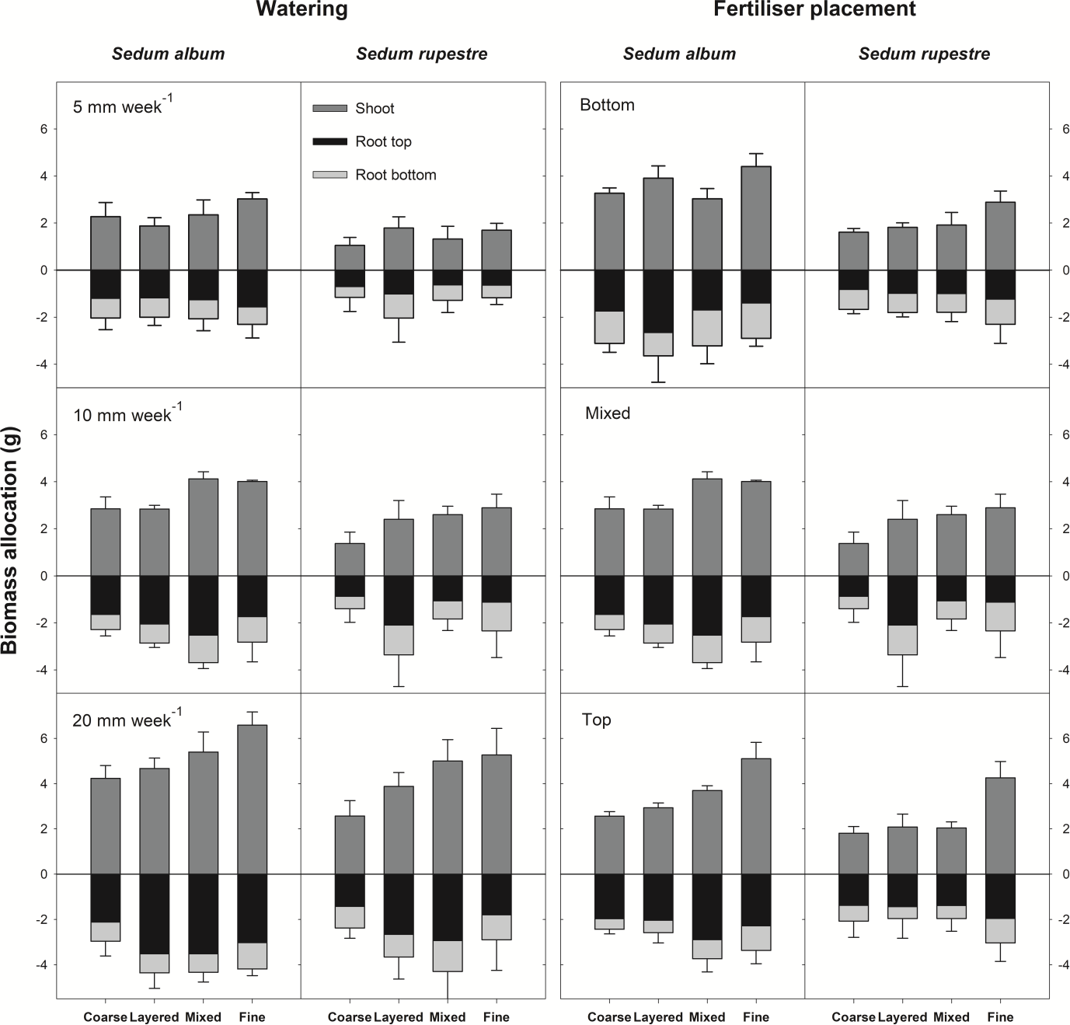

Fig. 1 Biomass allocation patterns in Sedum album and S. rupestre in response to watering (5, 10 or 20 mm week-1) and fertiliser placement (top half, bottom half or evenly distributed in pots) when cultivated in green roof substrates of contrasting structure. Note that root data are multiplied by a factor of 10 for better presentation

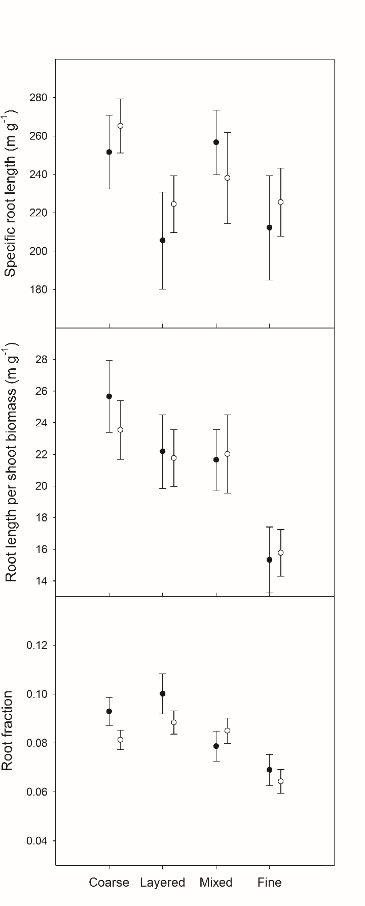
Fig. 2 Specific root length, root length per shoot biomass and root fraction (mean with 95% confidence interval) for Sedum album (white symbols ) and S. rupestre (black symbols) growing in green roof substrates of contrasting composition. Estimates are averaged over watering and fertilisation treatments

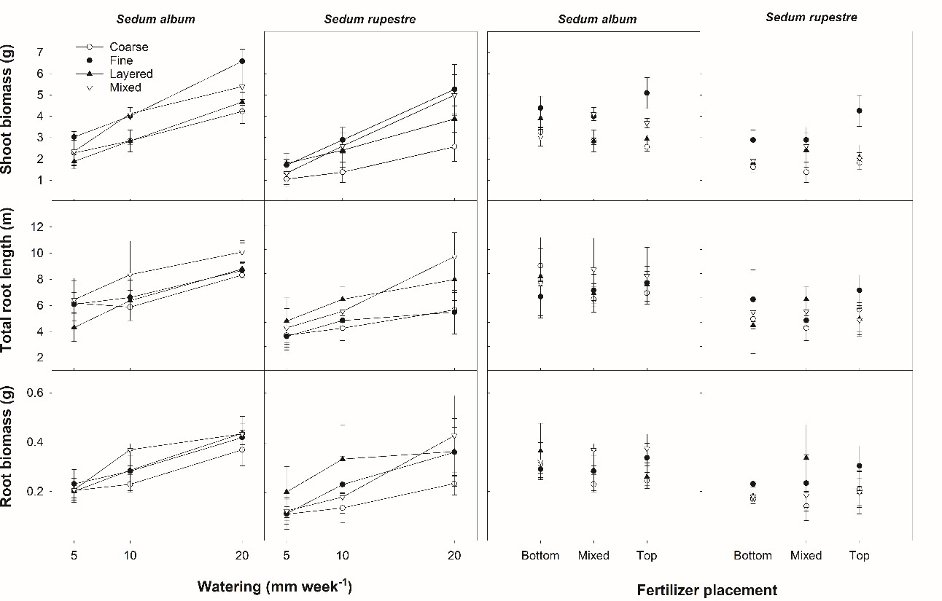

Fig. 3 Effects of watering, vertical fertiliser placement and substrate structure on shoot biomass, total root length and total root biomass (mean ± SD) in Sedum album and S. rupestre growing in green roof substrates of contrasting texture

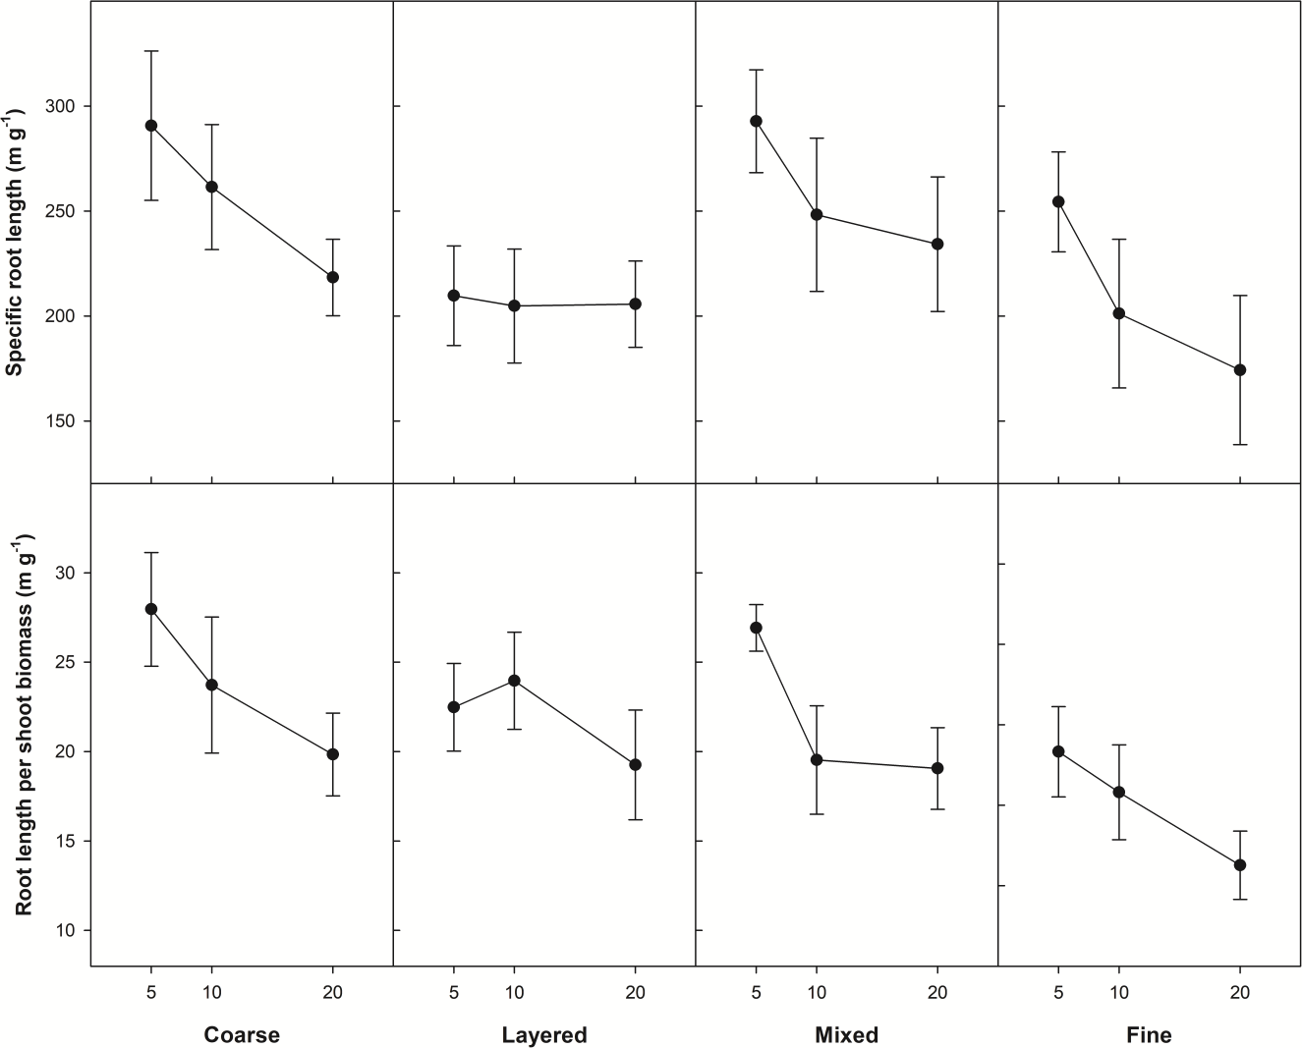

Fig. 4 Specific root length and root length per shoot biomass (mean with 95% confidence interval) of Sedum species growing in green roof substrates of contrasting composition receiving 5, 10 or 20 mm water per week. Estimates are averaged over species (S. album and S. rupestre)

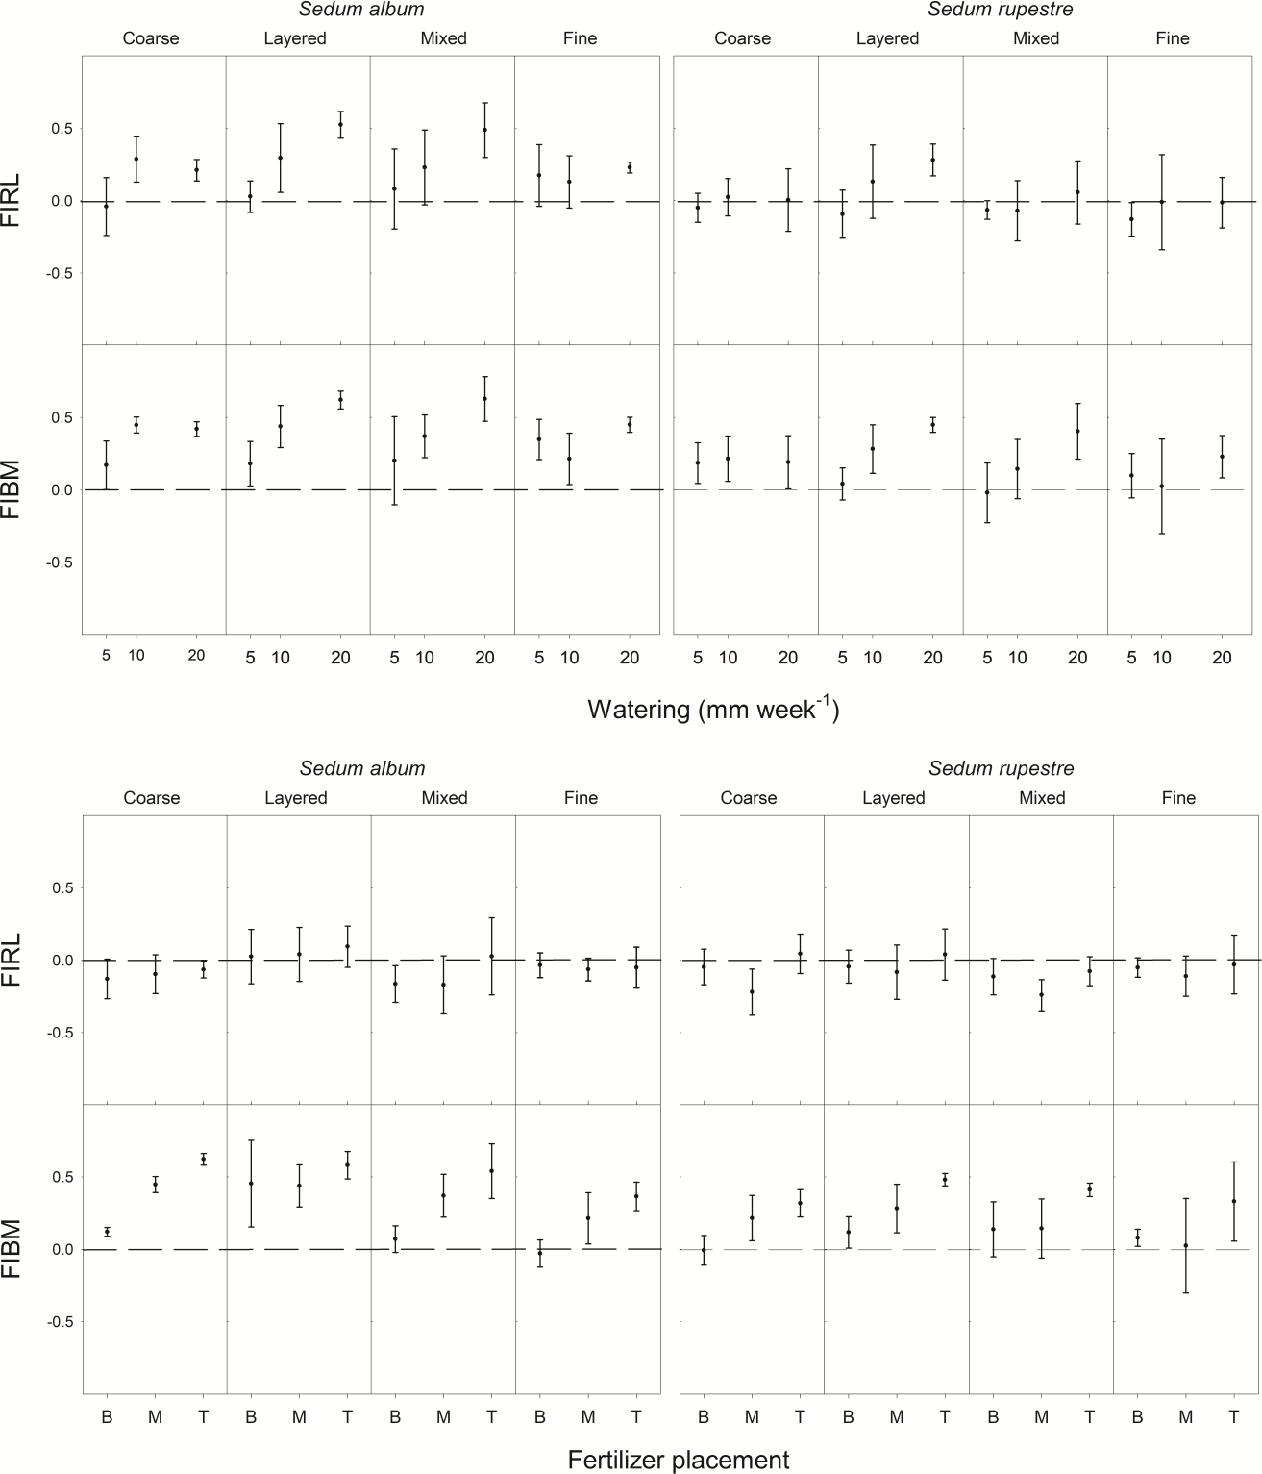

Fig. 5 Effects of watering (above) and vertical fertiliser placement (below) on indices of root foraging (mean with 95% confidence interval) based on root length (FIRL) or root biomass (FIBM) for two Sedum species grown in substrates of contrasting texture, receiving either 5, 10 or 20 mm irrigation per week or manipulation of vertical fertiliser placement in the pots (B = bottom, M = mixed, T = top). Indices were estimated as response in upper part of pot minus response in bottom part of pot divided by the sum

response for the whole pot. The dashed lines indicate when root length or root biomass is evenly distributed between the top and bottom parts of the pot

SUPPLEMENTARY MATERIAL

Sedum root foraging in layered green roof substrates

Peng Ji1, Arne Sæbø2, Virginia Stovin3, Hans Martin Hanslin2*

* Corresponding author: hans.martin.hanslin@nibio.no

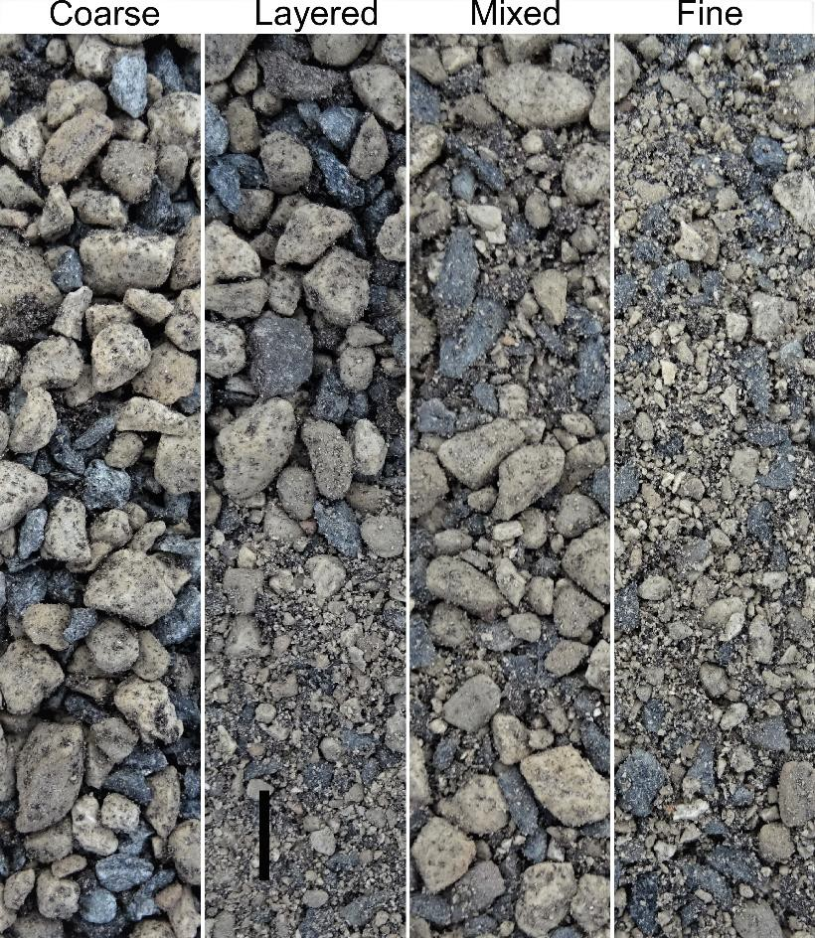
Fig. S1 Texture and layering in the four types of substrates used in the pot experiment. The full height of the columns corresponds to the substrate height of 9 cm used in the pots. Black bar is 1 cm.

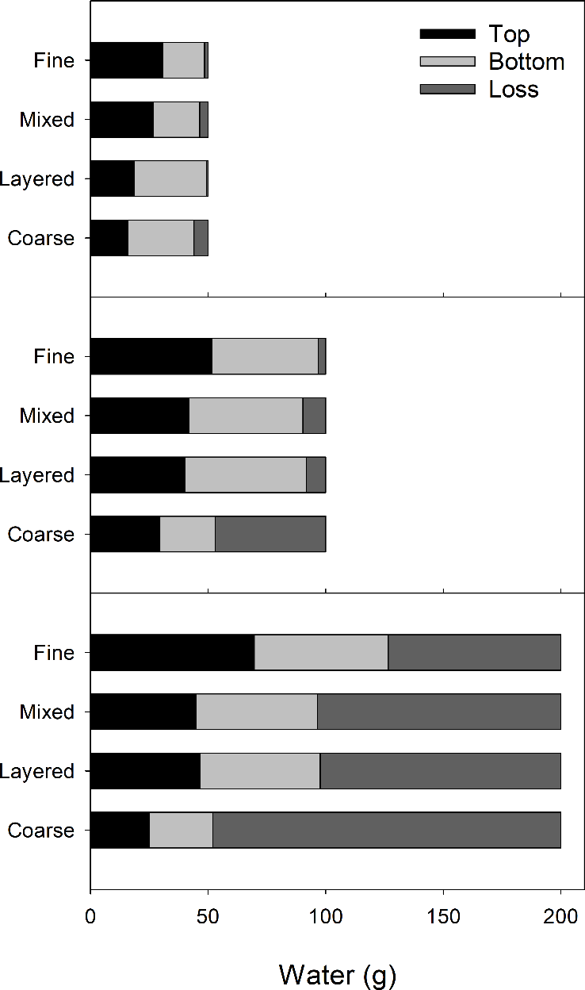
Fig. S2 The amounts of water lost and retained in the different vertical layers given 5, 10 or 20 mm of watering. The bottom figure shows the relationship between water added and water retained per pot (mean ± SD, n=3). Stippled line is the 1:1 relationship between added and retained.

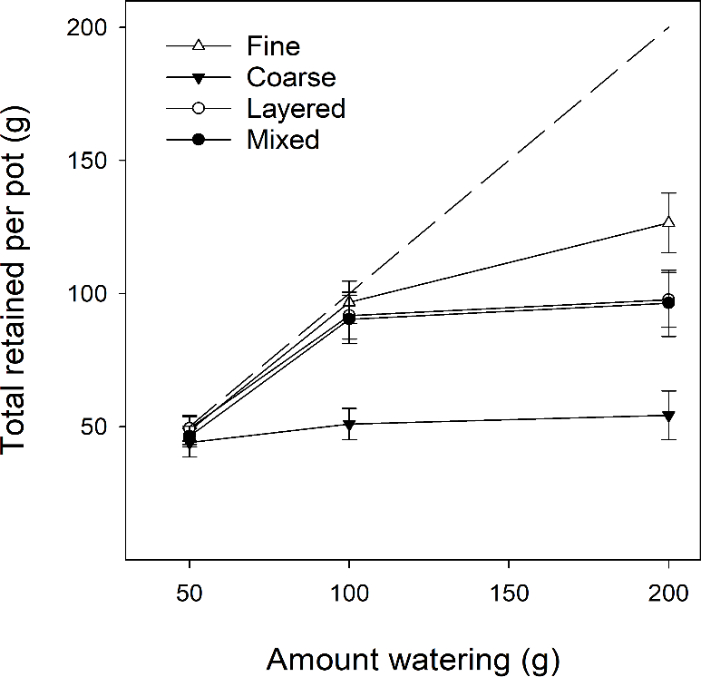

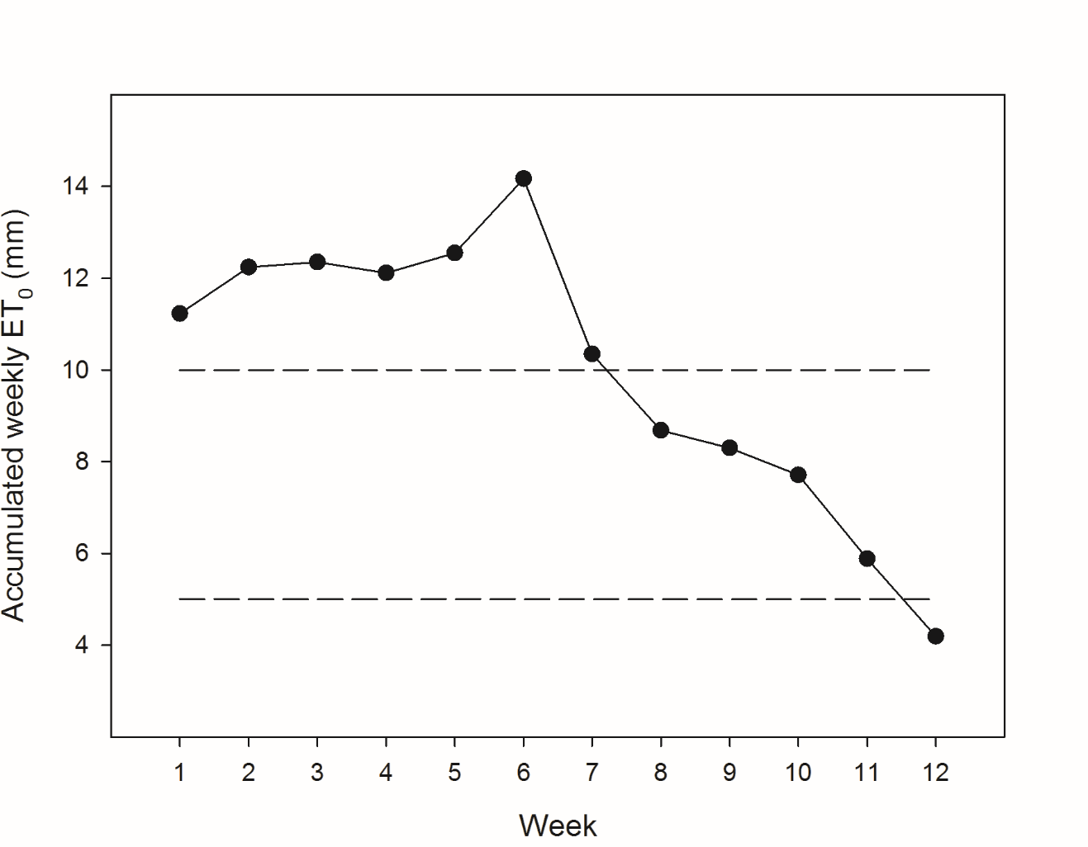
Fig. S3 Estimated cumulative weekly reference evapotranspiration (ET0) during the experiment. Dashed lines show the irrigation regimes of 5 and 10 mm week-1

Fig. S4 Contour plots showing the horizontal distribution of root biomass for three layers of the pot volume in a mixed substrate estimated as mean percentage (%) of root biomass per horizontal layer based on a sampling of 16 cubes per layer (n = 3). Pot base is 9 by 9 cm.

