Submitted version, final version in Land Use Policy:
Suškevičs, M., Eiter, S., Martinat, S., Stober, D., Vollmer, E., de Boer, C.L., Buchecker, M., 2019. Regional variation in public acceptance of wind energy development in Europe: What are the roles of planning procedures and participation? Land Use Policy 81, 311–323. https://doi.org/10.1016/j.landusepol.2018.10.032

©2018 Licensed under the Creative Commons CC-BY-NC-ND 4.0

--
Regional variation in public acceptance of wind energy development in Europe: what are the roles of planning procedures and participation?

Suškevičs, M.; Eiter, S.; Martinat, S.; Stober, D.; Vollmer, E.; de Boer, C. L.; Buchecker, M.

2 NIBIO – Norwegian Institute of Bioeconomy Research, P.O. Box 115, 1431 Ås, Norway sebastian.eiter@nibio.no
3 School of Geography and Planning, Cardiff University, Glamorgan Building, King Edward VII Avenue, Cardiff, CF10 3WA, Wales, UK martinats@cardiff.ac.uk
4 Institute of Geonics of the Czech Academy of Sciences, Department of Environmental Geography, Studentska 1768, 708 00 Ostrava, Czech Republic
ORCID: 0000-0003-4060-2009
5 UNIOS – University of Osijek, Faculty of Civil Engineering, Ul. kralja Petra Svačića 1, 31000, Osijek, Croatia dstober@gfos.hr
6 Centre of Renewable Energy of Estonian University of Life Sciences, Kreutzwaldi 5, Tartu 51014, Estonia elis.vollmer@emu.ee
7 Department of Urban and Regional Planning and Geo-Information Management, University of Twente, PO Box 217, 7500 AE Enschede, Netherlands c.deboer@utwente.nl
8 WSL – Swiss Federal Institute for Forest, Snow and Landscape Research, Economics and Social Sciences, Zürcherstrasse 111, CH-8903 Birmensdorf, Switzerland matthias.buchecker@wsl.ch

Highlights
- We conducted an expert survey about wind energy resistance in planning.
- Resistance links to planning quality in four supra-national European regions.
- Landscape encroachment is a major reason for resistance in most European regions.
- Lack of social justice ranks high in East- and South-Europe.
- Comprehensive strategic planning potentially reduces problems with resistance.

Graphical Abstract
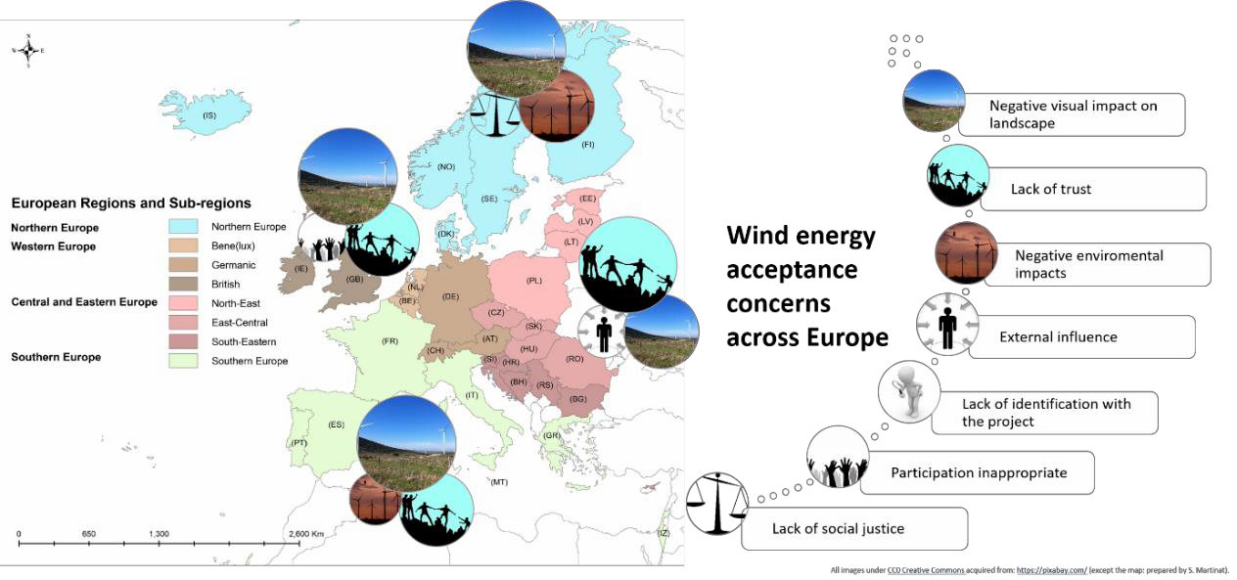

Abstract
The successful transition towards renewable energy (RE) technologies is closely intertwined with various societal aspects. Wind energy (WE) is one of the most controversial RE-types, possibly due to the multiplicity of related public concerns. Although some European country- comparisons exist, research concerning acceptance factors in different political and cultural planning contexts is scarce, especially in Eastern and Southern Europe. This paper explores the variation of (1) acceptance issues across Europe, and (2) patterns of strategic and local planning in affecting WE acceptance. We conducted an expert survey among the members of the COST Action ‘Renewable Energy and Landscape Quality’ and the association Wind Energy Europe. We found that acceptance issues – as perceived by the experts – across different regions in Europe share certain similarities, such as concerns about landscape impacts. The priority-levels of acceptance issues are specific to each region and link to the planning quality in that context. Planners’ and decision-makers’ increased awareness about the diversity of acceptance issues would allow them to design more appropriate strategic and local planning processes.
Keywords: landscape quality; multi-level governance; renewable energy; resistance; strategic planning; web-survey.

1. Introduction
Wind energy (WE) in Europe has been rapidly gaining importance over the last 20 years (Ellis and Ferraro, 2016; Fournis and Fortin, 2017; Haas et al., 2011). According to the European Network of Transmission System Operators for Electricity, wind energy contributed nearly 9% of Europe’s energy production in 2016: this was a third of the total renewable energy (RE) production (ENTSO-E, 2016). Since wind power installations are often perceived as exerting a strongly negative impact on the visual aesthetics of landscapes (Pasqualetti, 2011), wind energy is one of the most controversial RE types in terms of public acceptance. Many regions in Europe experience opposition to wind and other RE developments, and as such, adapting planning processes to minimise public resistance is crucial (Hyland and Bertsch, 2018).
Numerous case studies have been conducted on WE acceptance and planning in different countries across Europe. Far fewer comparative studies exist in e.g., England, Wales and

Denmark (McLaren Loring, 2007), the Netherlands, England and North-Rhine Westphalia (Breukers and Wolsink, 2007), Finland, Sweden and Norway (Liljenfeldt, 2015), France and Germany (Jobert et al., 2007), or Czech Republic and Austria (Frantál and Kucera, 2009). Research that compares and contrasts acceptance in various country and regional contexts is specifically lacking. This would be particularly valuable, as WE planning is closely related to diverse spatial planning systems, traditions and cultures across Europe (Nadin and Stead, 2013; Othengrafen, 2010; Reimer and Blotevogel, 2012). Thus, studying acceptance problems in this context provides important clues related to how synergies between planning procedures and energy policies can be identified and utilised in various socio-cultural contexts.
A number of socio-psychological, procedural and contextual factors affect social acceptance of RE technologies (Devine-Wright, 2007; Ellis and Ferraro, 2016; Huijts et al., 2012). Concerning socio-psychological factors, one of the most widely studied areas of research is related to landscape: foremost how the ‘resistance’ of WE can be explained by aesthetic concerns, wider (visual) impacts on landscape (Pasqualetti, 2011) or place attachment and identity (Devine-Wright and Howes, 2010). Another often highlighted aspect influencing WE acceptance is the process of realizing WE projects (Aitken, 2010; Anderson, 2013; Raven et al., 2009). Here, among the most important factors are found to be trust and procedural justice,
  - how the decisions are made (e.g., Walker et al., 2010), and distributional justice, i.e. how the benefits of decision-making are distributed (e.g., Cowell, 2010; Zoellner et al., 2008). With regard to contextual aspects, environmental concerns about WE are important. This includes potentially adverse impacts on biodiversity (Dai et al., 2015), but also aspects of the socio- cultural context of a given WE project (Jobert et al., 2007): such as the culture of communication and participation (Kontogianni et al., 2014). The current, mostly case study based literature indicates that the significance of different WE acceptance factors is still being debated (Huijts et al., 2012).
The role of procedural justice for social acceptance of RE projects is often particularly emphasized (Aitken, 2010; Pasqualetti, 2011). However, only a few studies have considered the impact of the strategic planning practices in Europe or the contribution of local participation to successful project implementation (Langer et al., 2017). Recent literature highlights that public participation in local renewable energy planning in Europe usually takes place at a late stage: such as the permitting phase, and only seldom in the need-determination phase (e.g., Devine-Wright and Howes 2010). Moreover, participation is often limited to one-directional information sharing and pursues primarily instrumental goals (legitimization of a project) (e.g., Aitken et al., 2016). Fournis and Fortin (2017) emphasize that different levels of analysis in studying WE acceptance are needed. They point out that research is mainly focused on the ‘micro-social’ level, i.e. the perceptions held by the individuals and social groups. However, not many studies consider wider levels of analysis, such as socio-political and regional aspects of WE acceptance.
This paper addresses the role of process- and contextual factors in affecting wind energy acceptance and their potential variance across Europe. We ask the following research questions:
    - What are the commonalities and differences in WE acceptance issues in various European regions?
    - How do strategic and local planning differ across Europe and how important are they as factors explaining WE acceptance issues?
These questions are interlinked; answering them will contribute to understanding the relationships between various spatial planning contexts in Europe and their links to WE acceptance issues. Our analysis draws on a recent expert survey conducted in the framework of the COST Action TU 1401 ‘Renewable Energy and Landscape Quality’.

The paper proceeds as follows. In Section 2, we review existing literature with a focus on how it discusses acceptance and resistance of RE technologies and wind energy in particular. Assuming that different planning contexts in Europe can be distinguished, we rely on spatial planning literature for depicting our analytical approach. In Section 3, we outline the methods for capturing and analysing the perspectives of experts. After presenting the survey results (Section 4), we set our findings into the context of empirical WE and planning literature and discuss the strengths and weaknesses of our approach (Section 5). We conclude with a set of implications for academia and practice (Section 6).

Literature review 2.1.Acceptance and resistance
The notion of ‘acceptance’ in the context of WE has been contested for quite some time (Ellis and Ferraro, 2016). One of the most well-known conceptual models (Wüstenhagen et al. 2007) proposes that social acceptance of RE technologies consists of three broad elements: socio- political acceptance, community acceptance, and market acceptance. On a ‘micro-social’ level, acceptance has been defined, for example, as a favourable response related to the proposed or in situ technology by members of a given social unit (Upham et al., 2015:103). Acceptance can be depicted as a continuum, where different levels of support can be distinguished, e.g., an attitude or action level (Langer et al., 2016). However, in RE acceptance research, often the inverse – resistance – is studied (Fournis and Fortin, 2017:2). In this study, we focus mostly on the latter, socio-political resistance, by discussing possible reasons why acceptance of WE is problematic in different regional contexts in Europe.

Regional differences and similarities in WE acceptance: lessons from case studies
As society-technology relationships of RE tend to be highly context-dependent, case studies are an important source of knowledge. During past decades, numerous case studies have been conducted on WE acceptance and planning in different countries across Europe. Existing research on WE acceptance tends to concentrate on West- and North-European countries, such as Austria (Höltinger et al., 2016), Switzerland (Walter, 2014), Germany (Jobert et al., 2007; Langer et al., 2016; Leibenath and Lintz, 2017; Leibenath et al., 2016), and the UK (Walker et al., 2014; Simcock, 2016). Far fewer studies about WE acceptance exist in Central and Eastern European (CEE) countries, e.g., Poland (Michalak and Zimny, 2011) or Czech Republic (Frantál and Kucera, 2009), and South-Europe, like Greece (Kaldellis, 2005; Kontogianni et al., 2014; Oikonomou et al., 2009), or Portugal (Delicado et al., 2014; Silva and Delicado, 2017). Case comparisons mostly focus on countries from similar socio-political contexts, e.g., England, Wales and Denmark (McLaren Loring, 2007) or Finland, Sweden and Norway (Liljenfeldt, 2015). However, research is scarce on comparing and contrasting acceptance in different socio-political contexts (e.g., Poland and Germany (Liebe et al., 2017)).
The available comparative studies have pointed out some general lessons. In places where biophysical conditions strongly support WE development (e.g. Scotland), people may have a higher acceptance of wind parks if they feel ownership towards the project (Enevoldsen and Sovacool, 2016). WE development is indeed different across various socio-political contexts in Europe, which in turn affects acceptance factors, e.g., financial participation is found to be more important in influencing acceptance in Germany than in France (ibid.). General WE acceptance levels are higher in Poland than in Germany, but procedural justice in both countries is more important than distributive justice (Liebe et al., 2017). Although information and participation are important in general, broad public participation seems to be considered as less important at the local level in France than in Germany (Jobert et al., 2007).

Analytical approach: regional perspectives on spatial planning and WE
Spatial planning at different governance levels can play a significant role in shaping WE acceptance. Strategic planning includes different approaches and measures, e.g., a strategic environmental assessment (SEA) procedure, where public and stakeholder participation are compulsory elements in democratizing the planning processes (Bonifazi et al., 2011; Phylip- Jones and Fischer, 2015). Strategic planning has the potential to direct developers, reduce uncertainty, and allow for the identification of adverse impacts at an early stage of WE projects (Simão et al., 2009). For example, existing research shows that a lack of strategic spatial planning in Belgium has led to a ‘wind rush’ to available land and competition between developers (Pepermans and Loots, 2013). Local planning can affect acceptance as well through the allocation of benefits and costs, as well as the implementation of participatory procedures.
To explore regional differences in WE acceptance, we differentiate between four supra- national large regions and eight subordinate regions across Europe (Fig. 1). Similar groupings of countries into large regions have been applied elsewhere to analyse RE acceptance (e.g., Heiskanen et al., 2007). For the eight sub-regions, our typology mainly rests on the spatial planning literature (Nadin and Stead, 2008; Newman and Thornley, 1996). Recent planning scholarship emphasizes that planning systems as well as planning cultures vary in Europe (Reimer and Blotevogel, 2012; Stead, 2013; Knieling and Othengrafen, 2015). The variation of legal and administrative procedures extends to how they are applied; further affecting the outcomes of decision-making (Reimer and Blotevogel, 2012; Munteanu and Servillo, 2014). In addition, for Eastern and Southern Europe, our typology rests on pragmatic reasons (e.g., to guarantee a more equal distribution of survey responses) and on historical considerations (e.g., legacies of the Habsburgian empire) (cf. Inglehart and Welzel, 2010; Jauhiainen, 2014). In these regions, not much WE acceptance or spatial planning specific literature exists.
A major drawback of any typology is an over-emphasis on certain aspects (like the formal structure of planning). This tends to neglect the ways the systems are functioning in practice (Nadin and Stead, 2008). However, as certain general similarities between planning system traditions can still be drawn, we are interested in testing if and how such differences play out in actual WE planning.

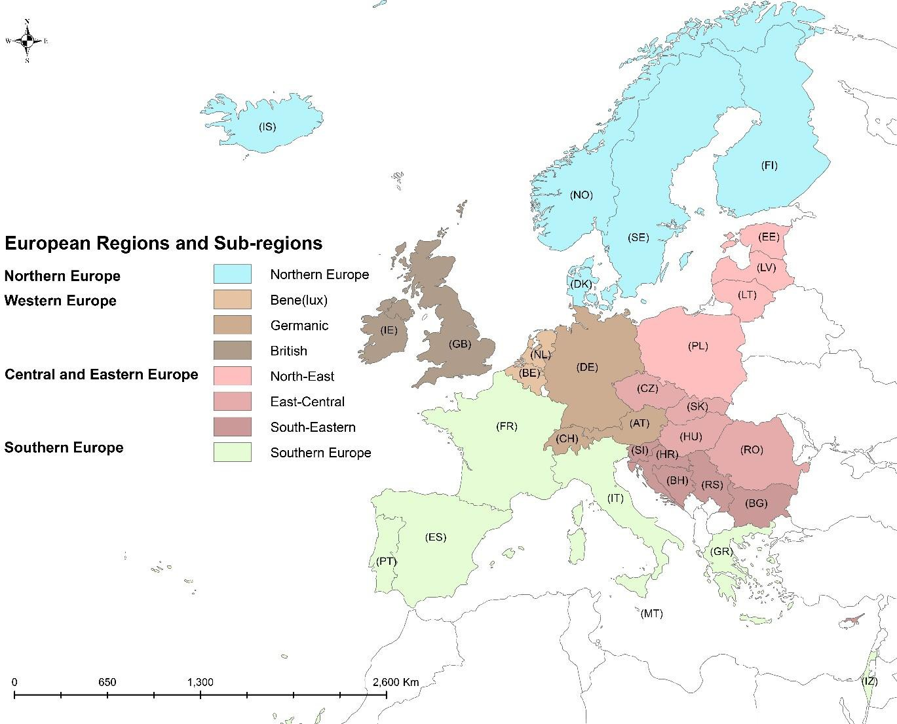
Figure 1. Regions for analysing WE acceptance across Europe. Note: France can be viewed as a ‘bridge’ between north Western and Southern Europe (Rivolin and Faludi, 2005). The full list of countries participating in COST Action TU1401 can be found at http://cost-rely.eu/about- the-action/lorem-ipsum. Maps prepared by S. Martinat.

Methods

  - Survey design and questionnaire content
The research strategy followed is primarily quantitative. An expert survey about participatory planning of WE projects was conducted in the framework of the COST Action TU 1401 ‘Renewable Energy and Landscape Quality’ (http://cost-rely.eu/). Initially it was accepted that expert assessments are ‘the expressions of informed opinion that experts make based on their knowledge and experience’ with respect to a technical problem (Bosetti et al., 2012:310). Expert surveys have been widely used in RE studies (e.g., Lee et al., 2009; Frantál et al., 2018). However, our results should be interpreted bearing in mind certain considerations, which we briefly discuss below (Section 5.3).
The survey was initiated, designed and set up mainly by the members of the WG3 ‘Socio- cultural Aspects of Sustainable RE Production’. We defined the content and structure of the questionnaire during several meetings of WG3, based on the experience of individual Action members, and a literature review. We used the keywords ‘acceptance’, ‘resistance’, ‘factors’, ‘wind energy’, ‘planning’, ‘Europe’ and ‘case study’ to search for literature in scientific databases and search engines, e.g., Google Scholar and Web of Science. Following the literature review key knowledge gaps were identified as discussed above: i) acceptance/resistance factors

(e.g., aesthetics and image) in different contexts, and ii) strategic and local planning of WE
(e.g., process-, outcome and contextual characteristics of planning).
The questionnaire (Appendix A) includes the following topics: strategic planning, community initiatives, local involvement and local acceptance. As specified in the research questions, we do not address the results of the survey in its entirety but focus on the following four topics as summarised below:
    - Explaining resistance: perceptions of reasons for resistance against WE, Question (Q)27. Literature suggests that resistance is mostly caused by:
      - a lack of procedural justice and/or trust in the project: situations where public participation procedures are designed and/or convened inappropriately (e.g., Raven et al., 2009: Walker et al., 2010),
      - a lack of social justice: situations where costs and benefits are not allocated in a fair way (see, e.g., Zoellner et al., 2008; Cowell, 2010),
      - concerns about local image: occasions when the reputation of a place is perceived as being negatively affected (e.g., Michel et al., 2015),
      - perceived encroachment into landscape: negative visual impacts of wind parks on landscape (e.g., Pasqualetti, 2011),
      - negative environmental impacts: adverse impacts on biodiversity, such as bird collisions with turbines (e.g., Dai et al. 2015),
      - negative external influence: local autonomy affected by actor(s) outside of the local context (e.g., Simcock, 2016).

    - Strategic planning is a general approach for guiding wind energy development (e.g., Simão et al., 2009; Cowell, 2010). It can include different tools and forms, such as requirements for setting target amounts of wind energy or defining priority areas for wind park development. Communication, public and stakeholder participation are important components of strategic planning that support social acceptance of wind energy development (Phylip-Jones and Fischer, 2015). Questions related to strategic planning concern:
      - expert perceptions about forms of strategic planning of wind energy (Q6);
      - quality of communication (Q8); and
      - actor involvement in the planning of priority areas (Q9; 10; 11; 12).

    - Local planning includes aspects of wind energy planning taking place at sub-national levels. Existing literature suggests that communication and involvement of different actors is of key importance in determining the acceptance of wind energy at the local level (e.g., Raven et al., 2009; Aitken, 2010; Aitken et al., 2016). Yet, the exact relevance and dimensions of participation are still debated. The questions focussing on local planning are related to:
      - perceptions on the quality of communication and deliberation (Q19; 21; 23);

      - timeliness of communication (Q20);
      - influence of specific actor groups on wind energy projects (Q22);
      - influence of local actor groups on decision-making (Q24).

    - Contextual aspects include the socio-economic, political and cultural context of wind energy planning, such as the culture of communication and patterns of government-led participation, as well as the ability of communities to self-organize through informal modes of participation (e.g., Kontogianni et al., 2014; Knieling and Othengrafen, 2015). In Q16 respondents are asked about the relevance of different barriers for WE production.

Questionnaire administration and sample
The English language questionnaire consists primarily of closed-ended questions. An initial draft of the questionnaire was pre-tested (internally) in early 2017 and revised according to the responses and comments received. The questionnaire was available online from 11th of May until 31st of August 2017 with reminders being sent in July and August. The survey was administered by distributing the link to the online questionnaire to two target groups of respondents: (1) the members of COST Action TU1401, covering 37 countries, and (2) RE experts outside the Action, in particular representatives of all national associations associated to the organization Wind Energy Europe, as well as other national contact points. The COST network consists of more than 200 individuals from academic, governmental, and non- governmental institutions. The COST Action members generally have either backgrounds in geography and related fields (e.g. landscape planning and architecture) or environmental sciences (e.g., science and technology studies, application of different RE technologies). The representatives of national wind energy associations are predominantly associated with technical disciplines (engineers, planners).
The target size of the sample was a minimum of two expert responses per country. The sample was not compulsory to be representative for the entire country, as we did not aim to compare results between single countries. We nevertheless assumed that the respondents were representative of persons who are knowledgeable of the WE planning situation in their countries. In capturing the answers from different countries, we also aimed for pan-European coverage. Altogether, we received 108 responses from 33 countries: including EU-28 as well as EU-candidate and adjacent countries (plus Israel). Most countries were represented with at least two responses; however, only one response was received from BA, IL, LT, PT, RS, SK, and SE. One of the respondents did not indicate their country. To guarantee an approximately equal distribution of responses, when grouping countries into regions (as outlined in Section 2.3), we also took into account the total number of responses received. The number of responses per large region is approximately 10, which is sufficient given that it is an expert survey. Exact response rates per questions are indicated in Appendix B.

Data analysis
Experts were asked to assess items according to a 5-point Likert scale, with 1 indicating the lowest and 5 indicating the highest value. Additionally, a 0-option was provided for expressing an inability to assess that particular item.
For analysing the results, we used the Statistical Program for Social Science (SPSS) v21 software. Regional differences were analysed by calculating ANOVA and conducting appropriate post-hoc tests. To explore reasons for resistance, we first conducted correlation

analyses and then used multiple regression in order to detect the effect of planning quality on resistance issues while controlling for contextual characteristics (e.g., Sposato and Hampl, 2018).

Results

  - Relevance of reasons for resistance
The most relevant reasons for resistance against WE projects in Europe (full sample) were found to be encroachment into landscape, lack of trust and environmental concerns.
The most significant differences across the large regions in terms of acceptance problems were concerns regarding external influence, local image, landscape and social justice (Appendix B: Table B.1). External influence was considered to be the most important concern in the CEE region and the least important in Northern Europe (post-hoc p=0.023). Concerns about the local image were considered as most important in Western Europe and least important in Northern Europe (post-hoc p=0.051). Perceived encroachment into the landscape was assessed as most relevant in Northern Europe and least relevant in the CEE region (post-hoc p=0.111). Finally, a lack of social justice was perceived to be most relevant in Western Europe and least important in Southern Europe (post-hoc p=0.068).
The most relevant reason for resistance in Northern, Western and Southern Europe was regarded to be encroachment into the landscape, whereas in the CEE region, lack of trust and lack of social justice ranked as the highest concern (Fig. 2).
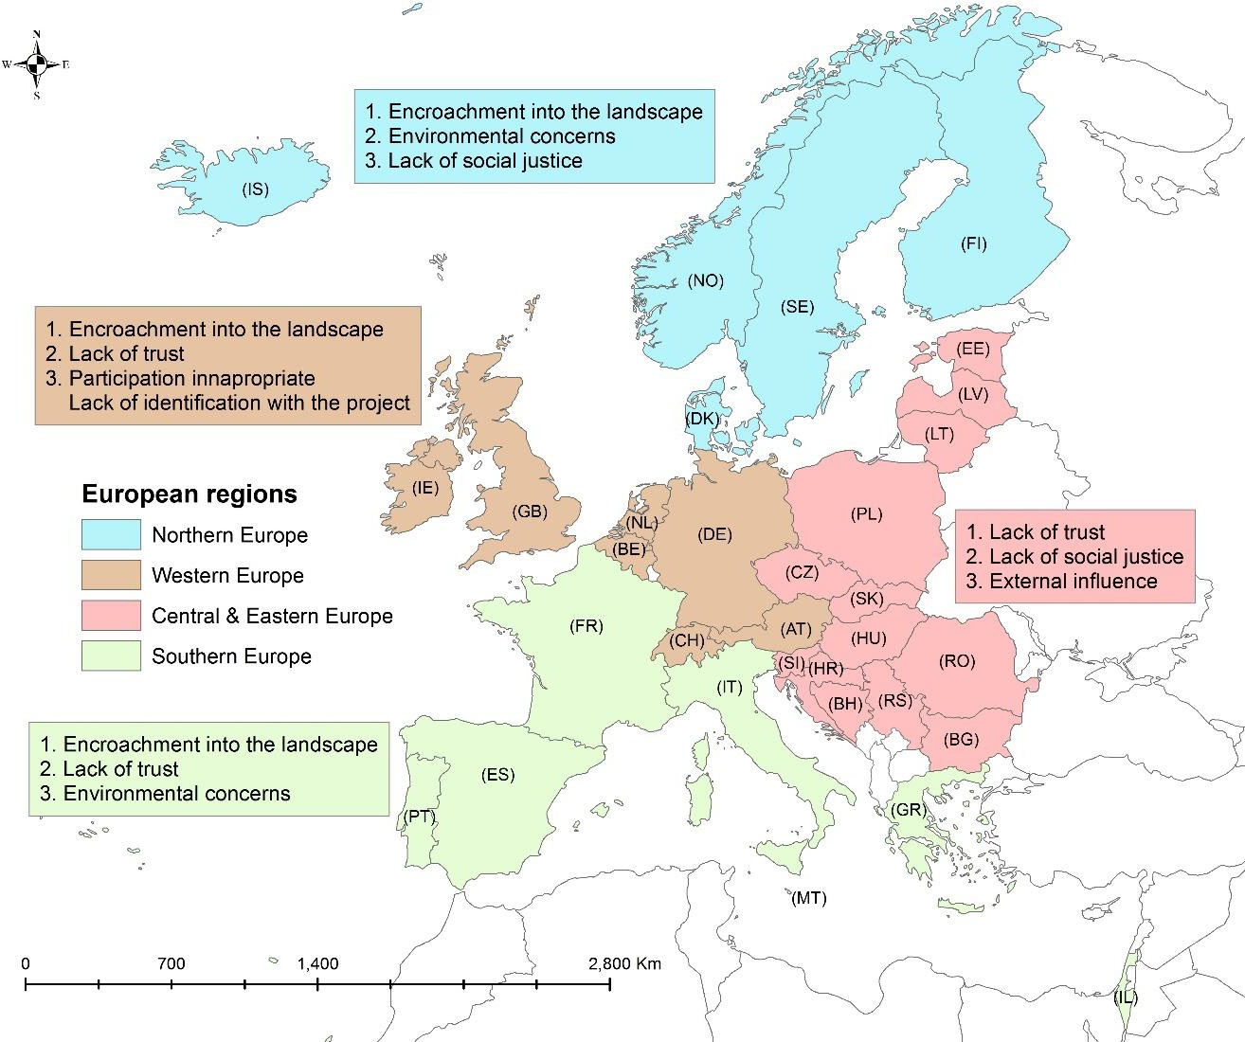

Figure 2. Ranking of reasons for resistance towards WE: some differences across large regions. For details, see Appendix B: Table B.1.

Differences across the sub-regions were more pronounced (Table 1). For example, local image was considered as more important in the Western European British sub-region (GB, IE) than in the CEE-South-Eastern sub-region (BG, SI, RS, HR, BA) (post-hoc p=0.024) or in Northern Europe (DK, NO, SE, FI, IS) (post-hoc p=0.010). Landscape was perceived to have significantly lower importance in the CEE South-Eastern sub-region than in several of the other (sub-)regions, for instance, the Northern Europe, Western Europe British or Western Europe Germanic (DE, AT, CH) sub-regions (for all these, post-hoc p=0.000). The ‘external influence’ variable was assessed lower in the Northern European region compared to the Western European British (post-hoc p=0.050) or CEE-East-Central sub-region (CZ, SK, HU, RO) (post- hoc p=0.019).

Table 1. Reasons for resistance towards WE: differences across sub-regions. Significance levels: **p<0,05; ***p<0,005.
No. | Resistance factors | Regional differences: sub-regions
 |  | Northern Europe (DK, NO,  SE, FI, IS) | W-Europe  - Bene(lux) (NL, BE) | W-Europe  - Germanic (DE, AT, CH) | W-Europe  - British (GB, IE) | CEE -  North-East (EE, LV, LT, PL) | CEE -  East- Central (CZ, SK, HU, RO) | CEE -  South-East (BG, SI, RS, HR, BA) | South- Europe (FR, GR, IT, PT,  MT, ES, IL) | p.
Overall mean |  | 3,45 | 3,69 | 3,74 | 4,38 | 3,90 | 3,63 | 3,37 | 3,38 | -
1 | Lack of social justice | 3,64 | 3,83 | 3,67 | 4,60 | 3,83 | 3,82 | 3,67 | 2,75 | 0,296
2 | Participation inappropriate | 3,33 | 3,50 | 4,22 | 4,20 | 4,17 | 3,58 | 3,50 | 3,11 | 0,310
3 | ***Local image concerns | 2,58 | 3,00 | 3,78 | 4,80 | 4,14 | 3,09 | 2,67 | 3,56 | 0,004
4 | ***Encroachment into the landscape | 4,58 | 3,83 | 4,56 | 5,00 | 4,50 | 4,25 | 2,56 | 4,11 | 0,000
5 | Environmental concerns | 4,30 | 3,67 | 3,75 | 4,40 | 3,29 | 3,42 | 3,89 | 3,67 | 0,527
6 | Conflict | 3,50 | 3,50 | 3,22 | 3,60 | 3,57 | 2,82 | 3,22 | 3,13 | 0,810
7 | **External influence | 2,36 | 3,50 | 2,71 | 4,40 | 3,60 | 4,20 | 3,17 | 2,88 | 0,014

No. | Resistance factors | Regional differences: sub-regions
 |  | Northern Europe (DK, NO,  SE, FI, IS) | W-Europe  - Bene(lux) (NL, BE) | W-Europe  - Germanic (DE, AT, CH) | W-Europe  - British (GB, IE) | CEE -  North-East (EE, LV, LT, PL) | CEE -  East- Central (CZ, SK, HU, RO) | CEE -  South-East (BG, SI, RS, HR, BA) | South- Europe (FR, GR, IT, PT,  MT, ES, IL) | p.
8 | Lack of identification with the project | 3,36 | 4,00 | 3,78 | 4,40 | 3,71 | 3,83 | 3,25 | 3,33 | 0,638
9 | Lack of trust | 3,36 | 4,33 | 4,00 | 4,00 | 4,25 | 3,67 | 4,43 | 3,88 | 0,795

Participatory wind energy planning and its regional variation
Based on the review of the available literature, certain variables related to planning can be expected to be among the key factors leading to higher acceptance. Therefore, we first take a closer look at the descriptive statistics of these planning factors, including their most relevant (significant) differences across Europe (Section 4.2).

Strategic planning
At the strategic planning level, regional differences in two variables 1) the general planning pattern and 2) the communication quality turned out to be statistically significant.
      - Planning pattern
The respondents were asked to characterize the situation of strategic planning of WE in their country based on a set of pre-defined topics (Q6, see Appendix A). The most common crucial aspects of strategic planning are the definition of the target amount of renewable energy, priority areas, and participatory procedures for involving the public (Fig. 3, details in Appendix B: Table B.2).
Significant differences among large regions occur in terms of provision of communication materials (p=0.013) and definition of priority areas (p=0.015), but also in defining areas for not developing WE (Table B.2). Providing communication materials seems to be more common in Western and Northern Europe, whereas least experienced in the CEE region. Among the sub- regions, only the ‘priority areas’ variable differed significantly (post-hoc p=0.085), where the pattern is similar to the large regions: priority areas seem to be defined more commonly in the Southern Europe (FR, GR, IT, PT, MT, ES, IL) than in the Western European Germanic sub- region (DE, AT, CH).

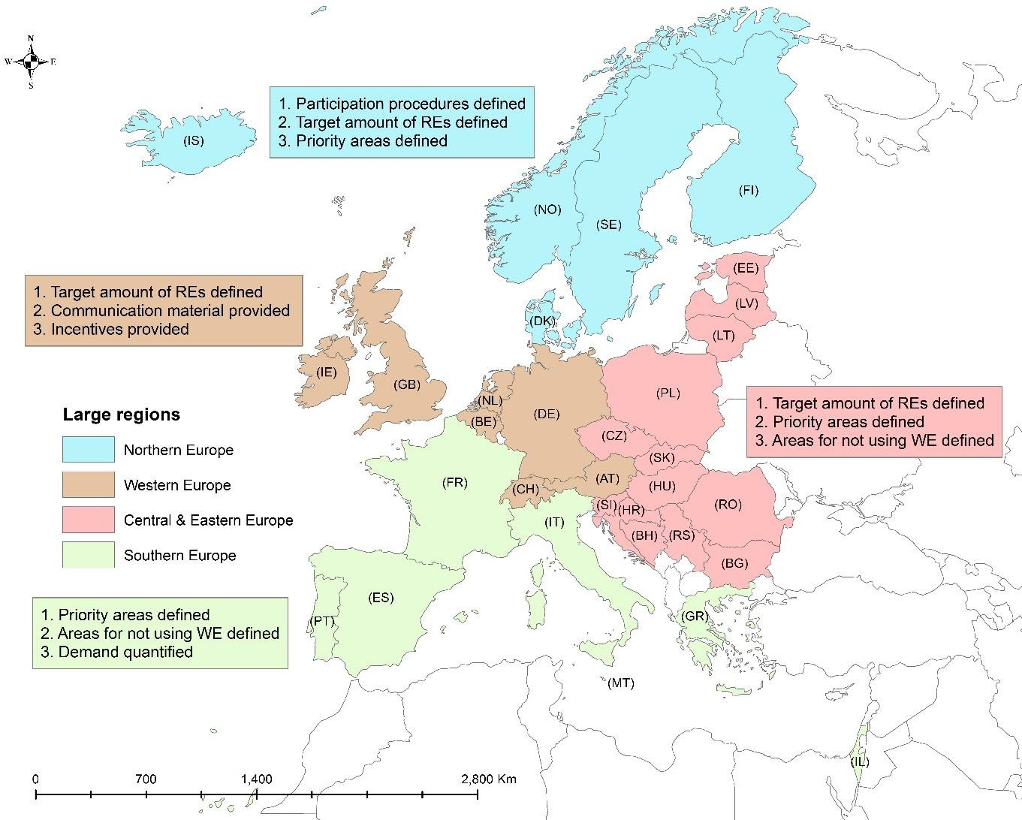
Figure 3. Ranking of strategic planning forms: summary and regional differences among large regions. Details in Appendix B: Table B.2.

      - Communication quality
Respondents were asked to assess the quality of communication at the strategic planning level (Q8). We found significant differences (p=0.003) between the large regions concerning how the quality of communication content was evaluated. Respondents from the Western European region tended to perceive communication quality considerably higher (mean=3.32) than in the Northern (mean=2.21) (post-hoc p=0.06), CEE (mean=2.03) (post-hoc p=0.002), and South European region (mean=2.00) (post-hoc p=0.038).
Among the sub-regions, less significant differences existed regarding the content quality of communication (p=0.028) and final decision-making (p=0.073). Content quality was assessed more positively in the Western European British (GB, IE) (mean=3.50) and Western European Germanic sub-regions (DE, AT, CH) (mean=3.20) than in the CEE-East-Central sub-region (CZ, SK, HU, RO) (mean=1.69). Regarding the communication quality on final decision- making, the Western European British sub-region (UK, IE) (mean=3.50) performed substantially better than the CEE-East-Central sub-region (CZ, SK, HU, RO) (mean=1.77).

Local planning
At the local planning level, the timing of communication and influence of actors turned out to be significantly different among the regions.

      - Timing of communication
We were interested in whether the respondents from different European regions perceived the timing of communication differently (Q20). We found a certain variation across large regions (p=0.052), which foremost concerned the Northern European and CEE regions (post-hoc p=0.034): earlier communication (e.g., already before the planning process) is more frequent in Northern Europe (sum mean=7.15) than in the three other regions, e.g., the CEE region (mean=4.32). No significant differences regarding this variable were found among the sub- regions, which certainly can be due to the small sample sizes.
      - Influence on decision-making by potentially relevant actor groups
Across the full sample, local councils and local authorities were assessed to be the most influential actor groups. However, we found significant differences in how the respondents from different large regions perceived the influence of certain stakeholder groups, especially local councils, interest groups and the wider public (Appendix B: Table B.3). Local councils were perceived to have a considerably higher influence in Western Europe than in the CEE region (post-hoc p=0.018) and in Southern Europe (post-hoc p=0.054). Interest groups were seen as having higher influence in Western Europe, too, as compared to Northern Europe (post- hoc p=0.044) or Southern Europe (post-hoc p=0.097). The wider public was considered to have a higher influence in Western Europe than in the CEE region (post-hoc p=0.039).
Among the sub-regions, the impact of local councils (p=0.000) and local authorities (p=0.000) was perceived differently with high significance. There were also certain differences in how the influence of interest groups was assessed (p=0.079) (Table 2). Local councils were rated to have considerably higher influence in the Western European British (GB, IE) and Western European Germanic sub-regions (DE, AT, CH) but also in Northern Europe, than for instance, in the CEE-South-Eastern sub-region (BG, SI, RS, HR, BA) (post-hoc p=0.000). Local authorities seem to be more important in Northern Europe (DK, NO, SE, FI, IS) and the Western European British sub-region (GB, IE) than in the CEE-South-Eastern sub-region (BG, SI, RS, HR, BA) (post-hoc p=0.007 and 0.002, respectively). Authorities’ importance was also rated differently within the CEE-region: e.g., they are more important in the CEE-East-Central sub-region (CZ, SK, HU, RO) as compared to the CEE-South-Eastern sub-region (BG, SI, RS, HR, BA) (post-hoc p=0.000).

Table 2. Perceived influence of different actor groups at the local planning level: differences across sub-regions. Significance levels: **p<0.05;
***p<0.005.

No. | Actor groups | Regional differences: sub-regions
 |  | Northern Europe (DK, NO,  SE, FI, IS) | W-Europe  -  Bene(lux) (NL, BE) | W-Europe  -  Germanic (DE, AT, CH) | W-Europe - British (GB, IE) | CEE -  North- East (EE, LV, LT, PL) | CEE -  East- Central (CZ, SK, HU, RO) | CEE -  South- East (BG, SI, RS,  HR, BA) | South- Europe (FR, GR, IT, PT,  MT, ES, IL) | p
Overall mean |  | 3,02 | 3,55 | 3,34 | 3,32 | 3,09 | 3,22 | 2,67 | 2,83 | -
1 | ***Local council | 3,58 | 3,50 | 4,00 | 4,00 | 3,00 | 3,90 | 2,78 | 3,14 | 0,000
2 | ***Local authorities | 3,62 | 3,50 | 3,50 | 3,80 | 3,43 | 3,91 | 2,44 | 3,14 | 0,000
3 | **Local interest groups | 2,77 | 3,83 | 3,33 | 3,20 | 3,29 | 3,36 | 3,11 | 2,71 | 0,079
4 | Local/regional NGOs | 2,62 | 3,60 | 3,00 | 3,00 | 3,14 | 2,91 | 2,67 | 2,86 | 0,306
5 | Wider local public | 2,54 | 3,33 | 2,89 | 2,60 | 2,57 | 2,00 | 2,33 | 2,29 | 0,121

Contextual aspects
We consider ‘barriers for WE production’ (in the questionnaire referring to community initiatives, Appendix A: Q16) as a proxy indicator for the socio-economic, political and cultural context of the regions. The results show that overall, the main deficits are found in the lack of financial resources and the lack of national incentives, i.e. the non-social factors (Appendix B: Table B.4). The main regional differences, however, concerned social context factors. The large regions differed significantly in how the lack of communication culture and lack of self-organization culture were perceived (Table B.4). Lack of communication culture was assessed as significantly less problematic in Northern Europe than in Western Europe (post-hoc p=0.046) and in the CEE region (post-hoc p=0.053). Regarding lack of self- organization, the North European region differed from the CEE region (post-hoc p=0.031): the lack of self-organization was perceived to be more problematic in the CEE region than in Northern Europe.
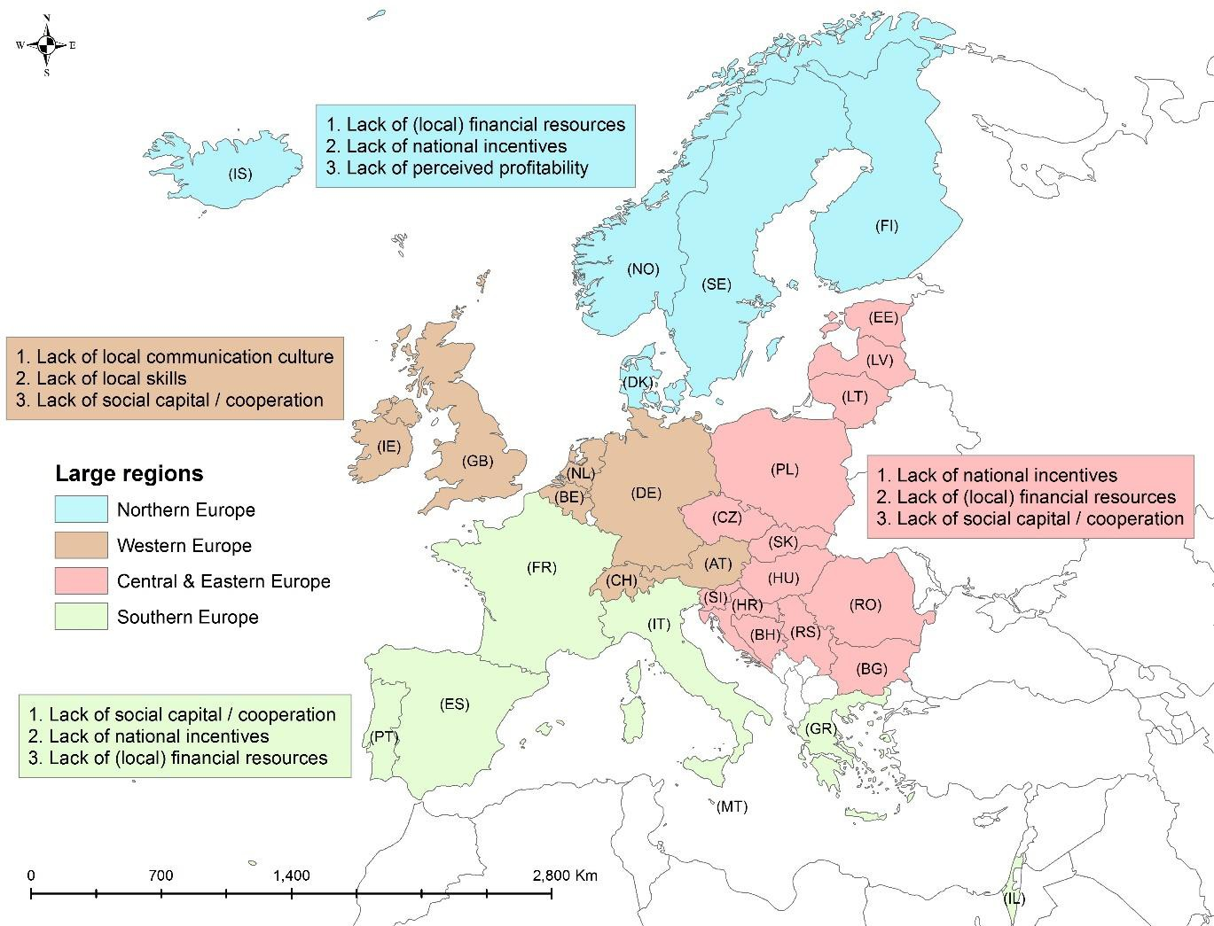
Figure 4. Ranking of the perceived importance of contextual aspects in WE planning: some regional differences. Details in Appendix B: Table B.4.

Among the sub-regions, differences were slightly more pronounced regarding self-organization (p=0.015). Lack of self-organization is perceived as less problematic in Northern Europe (DK, NO, SE, FI, IS) than in the CEE-East-Central sub-region (CZ, SK, HU, RO) (post-hoc p=0.010). In addition, the relevance of the variable of lack of financial resources was somewhat significantly differently assessed (p=0.070): the Western European Bene(lux) sub-region (NL,

BE) perceived this aspect to be less problematic than the CEE-East-Central (CZ, SK, HU, RO) sub-region (post-hoc p=0.036).

4.4.Resistance reasons and planning: explaining resistance
The performed regression analyses explored the relationships between resistance and certain planning variables. A summary of the results is presented here. A number of relevant reasons for resistance of WE-projects appeared to be substantially influenced by the quality of planning and certain contextual variables.
The linear regression analyses suggest that strategic and local level planning, and also contextual aspects might be important factors explaining the level of perceived encroachment into the landscape (adjusted r2=0.52), social conflicts associated to WE (in terms of pre-existing conflicts in a community) (r2=0.50), external influence (r2=0.37) and inappropriate participation (lack of procedural justice) (r2=0.36) (Table 3).
The most important explaining variables at strategic planning level seem to be the general strategic planning and communication quality. These were mostly negative influence factors: respondents who perceived strategic planning to be more regulated were less likely to perceive aspects related to social justice, environment or conflict to be problematic. At the local level, the influence of local actors was the most important explaining variable: the more influence the actors were perceived to have, the less social justice, participation and conflicts were considered to be problematic. This pattern was reversed in the case of the ‘local image’ and ‘landscape’ factors: the more influence the actors would have, the more problematic image and landscape would be perceived. For example, the factor of landscape was best explained by patterns of overall strategic planning (beta=0.506), communication quality (beta=–0.453), local actor influence (beta=0.396) and timing of communication (beta=– 0.306), although it was also explained by certain socio-economic aspects such as lack of social capital (beta=–0.303) and lack of resources (beta=0.308).

Table 3. Results from linear regression analysis. Dependent variable: resistance factors. ‘Don’t know’-responses in all variables are coded as 0; cases with missing values were excluded. Significance levels: *p<0.05; **p<0.005.

Category of variable | Resistance factor | Social justice |  | Participation inappropriate |  | Local image |  | Landscape |  | Environment |  | Conflict |  | External influence |  | Lack of identification |  | Trust
 | Adjusted r2 | 0,175 |  | 0,362 |  | 0,206 |  | 0,523 |  | 0,250 |  | 0,498 |  | 0,368 |  | 0,148 |  | 0,049
 | Variable | Beta | p. | Beta | p. | Beta | p. | Beta | p. | Beta | p. | Beta | p. | Beta | p. | Beta | p. | Beta | p.
Strategic planning: general patterns | Priority areas defined (Q6) |  |  |  |  |  |  | -,255 | ,037* |  |  | ,556 | ,000**
 | Financial participation regulated (Q6) |  |  | ,593 | ,000**
 | Overall strategic planning (Q6_sum) | -,354 | ,026* |  |  |  |  | ,506 | ,001** | -,409 | ,007** | -,700 | ,000**
Strategic planning: communication & participation | Communication quality (content) (Q8) | ,398 | ,029* |  |  |  |  | -,453 | ,004** | ,537 | ,001**
 | Communication quality (final decisions) (Q8) | ,358 | ,077 |  |  |  |  |  |  |  |  | ,547 | ,000**
 | Political resistance (Q12) | ,198 | ,110 | ,218 | ,095 |  |  | ,186 | ,080 |  |  |  |  | ,404 | ,001**
 | Communication time (Q20) |  |  |  |  | -,238 | ,050 | -,306 | ,013* |  |  |  |  |  |  | -,289 | ,043*

Category of variable | Resistance factor | Social justice |  | Participation inappropriate |  | Local image |  | Landscape |  | Environment |  | Conflict |  | External influence |  | Lack of identification |  | Trust
 | Adjusted r2 | 0,175 |  | 0,362 |  | 0,206 |  | 0,523 |  | 0,250 |  | 0,498 |  | 0,368 |  | 0,148 |  | 0,049
 | Variable | Beta | p. | Beta | p. | Beta | p. | Beta | p. | Beta | p. | Beta | p. | Beta | p. | Beta | p. | Beta | p.
Local planning: communication & participation | Deliberation quality (Q23) |  |  |  |  |  |  | ,226 | ,085
 | Communication quality (Q21) | -,281 | ,097 |  |  |  |  | ,342 | ,031* | -0,39 | ,015** | -,481 | ,001** |  |  | -,294 | ,053
 | Local actor influence (Q24) | -,523 | ,005* | -,422 | ,004** | ,447 | ,000** | ,396 | ,004** |  |  | -,327 | ,014* | ,273 | ,049* | ,293 | ,033*
Contextual aspects | Lack of social capital (Q16) |  |  |  |  |  |  | -,303 | ,015* |  |  |  |  | ,301 | ,017*
 | Lack of communication culture (Q16) |  |  | ,263 | ,091
 | Lack of financial resources (Q16) | ,177 | ,186 |  |  |  |  | ,308 | ,010* | ,295 | ,026** | -,228 | ,039*
 | Lack of national incentives (Q16) |  |  | ,269 | ,055 |  |  |  |  | -,222 | ,092 | ,183 | ,096 |  |  |  |  | ,238 | ,098
 | Lack of self- organization (Q16) |  |  | -,272 | ,093

Discussion
This study provides an overview of WE acceptance concerns – as perceived by experts – at the pan-European level and across supra-national regions. It further clarifies some links between WE acceptance and planning, with a focus on levels of strategic and local planning, as well as their contexts. We proceed to discuss our findings in light of the initially posed research questions.

What are the commonalities and differences in WE acceptance concerns and planning variables in European regions?

Acceptance concerns
Landscape is, as was expected, of high overall importance for WE-acceptance in almost all regions and sub-regions. This is in line with findings from many previous studies, according to which concerns about visual and aesthetic impacts of WE are a dominant reason for opposing WE projects (Pasqualetti, 2011). However, landscape seems to be less of an issue in the CEE region, especially in the CEE South-Eastern (Bulgaria, Slovenia, Serbia, Croatia, Bosnia & Herzegovina) sub-region, where concerns about the lack of trust and social justice are dominant. This characteristic is shared by the Eastern European countries, possibly due to their shorter histories of participatory decision-making traditions and less intensive environmental education, which supports voicing more concerns about environmental justice (Paloniemi et al., 2015). However, in line with previous research (e.g., Langer et al., 2016; Wolsink, 2010) our results suggests that a lack of trust in experts and authorities is not only a problem in the CEE region.

Planning variables
It was found that i) certain aspects of strategic planning, ii) communication timing, quality (at strategic and local level), influence of local actors, and finally, iii) certain socio-cultural contextual aspects are perceived significantly differently across the identified regions.
The findings support the argument that the general socio-economic as well as cultural contexts in the regions can partially explain the differences in expert assessments (Knieling and Othengrafen, 2015; Othengrafen, 2010; Reimer and Blotevogel, 2012). Some planning variables, such as the provision of communication materials, perceived communication quality (strategic planning level) or influence of key actors in WE development (local planning level) are perceived to be higher in Western Europe than in other regions. This is in line with previous studies, as communicative planning has longer traditions in Western and Northern parts of Europe (Othengrafen, 2010).
The sub-regional division enabled us to highlight some differences in a more detailed way. Within the CEE region, respondents from the CEE North-East and East-Central region gave considerably higher ratings than those from the CEE South-Eastern region. In particular, the CEE South-Eastern sub-region stands out in several respects. Respondents from this sub-region gave significantly lower scores for several acceptance concerns as well as for different participatory planning variables. Spatial planning in several countries, such as Serbia (Nedović- Budić and Cavrić, 2006), has been influenced by former common historical, political and cultural contexts. In addition, there has been varying levels of establishment of RE systems in these countries owing to the development of their respective institutional frameworks and national policies for RE (Karakosta et al., 2012). In general, the CEE South-Eastern region has a quite high potential for WE development, but areas best suitable for it are highly spatially

dispersed (Ban et al., 2013). Apart from the biophysical constraints, some institutional challenges related to WE planning are hindering its development. For example, some of the countries, such as Bulgaria or Bosnia-Herzegovina, do not yet have set specific targets or have launched policies for RE development, possibly due to structural changes in their economies, complex administrative procedures impeding cooperation and other similar reasons (Karakosta et al., 2012; Punda et al., 2017).
Lower scores in the assessments were also characteristic to the Southern European region, for instance, in terms of communication quality, timing of communication or actor influence. An explanation for this could be that in several of the South European countries, there is more focus on social (distributional) justice than on procedural justice (Delicado et al., 2014), as the latter is still in a developing stage. This tendency can also partly be explained by the spatial planning context in general: in South-European countries, informal forms of communication and action tend to be more common (Reimer and Blotevogel, 2012).

How important are strategic, local planning and contextual factors for WE resistance?

Overall patterns
In determining planning outcomes, the communicative dimension of planning processes usually matters as much as the technical-analytical side (Simão et al., 2009). Existing research strongly highlights that the involvement of key actors in higher-scale decision-making about RE is a crucial factor affecting acceptance (Fast, 2013; Langer et al., 2016; McLaren Loring, 2007; Wolsink, 2010). Our survey supports this: inadequate participation and a lack of identification with the project were considered as being among the key reasons for resistance to WE development. There appeared, however, to be a negative correlation between higher communication quality and landscape concerns, which is generally in accordance with previous research from similar contexts, e.g., planning nature conservation measures (Schenk et al., 2007). In our study, interestingly, procedural issues appeared to be mainly an issue in Western Europe where participatory planning quality tends to be more advanced. This might be explained by the publics’ higher expectations regarding the degree of its involvement (Simcock, 2016).

Strategic planning
Strategic planning provides frameworks and visions for balanced territorial development, particularly emphasizing qualities of places and the spatial impacts of decisions (Albrechts, 2006). Therefore, strategic planning of WE not only involves technical analyses but also deals with environmental and socio-economic complexities (Simão et al., 2009).
In our study, the most common strategic planning aspect is the definition of target amount of WE. This is likely the result of respective EU-policies and legislation on renewable energy sources (e.g., the Renewable Energy Directive, 2009). However, other factors, such as the definition of priority areas and participation procedures stand out in the expert assessments, and can be important for acceptance. Previous studies suggest that local authorities often feel unsettled if there are only general siting regulations for WE (Fournis and Fortin, 2017:9). Seeking to organically integrate wind farms into the landscape on a national or regional level can, however, be a challenging task: a strategic search for the areas best suitable for WE and being sensitive to local contexts at the same time includes nearly inevitable trade-offs for, e.g. environmental justice (Cowell, 2010). Strategic planning of WE can take various forms and several studies from West Europe, e.g., France, Germany, Austria (Höltinger et al., 2016; Nadaï

and van der Horst, 2010; Ohl and Eichhorn, 2010) indicate that, e.g. the definition of suitability and exclusion zones for WE does not per se guarantee higher acceptance, as much depends on the actual procedures. Our results from the linear regression suggest that a more comprehensive strategic planning approach tends to reduce problems with resistance, such as stakeholder conflicts, environmental concerns and social justice (Table 3 above). More specifically, we found a significant negative correlation between the definition of priority areas and landscape concerns. Hence, the more precisely that priority areas are defined, the less likely the development of WE seems to interfere with perceived landscape quality.

Local planning
WE impacts become most discernible at the local level. Previous studies underline that the ways in which local planning procedures are exercised can affect acceptance to a great extent (Enevoldsen and Sovacool, 2016; Rydin et al., 2015; Silva and Delicado, 2017). We found a strong negative correlation between communication time and different acceptance factors, namely local image, landscape and lack of identification with the project. This supports the argument found in many of existing studies that earlier communication is needed to achieve higher acceptance levels (Eiter and Vik, 2015; Langer et al., 2017; Schenk et al., 2007).
The influence of different actors appears to be strongly associated with several of the reasons for resistance, yet having mixed effects. We found that the less influence actors have the more likely it is that problems with social justice, participation and conflictive situations can arise. Some earlier studies (e.g., Buchecker et al. (2013)) also support this. On the contrary, the more influence actors have, the more there tends to be problems with landscape and local image. This might mean that involvement of selected stakeholders does not solve these issues adequately: more innovative or inclusive forms of participation could be needed. For example, a case study on local planning of WE in Sweden showed that the processes often include governmental actors but exclude others (Gustafsson et al., 2015). A study of Frantál et al. (2017) about wind farms in Iceland showed that new methods like mental mapping could be beneficially utilized to involve various actors in the WE planning processes.

Contextual aspects
Our study suggests that two variables – lack of social capital and lack of finances – tend to be correlated with the reasons for resistance. The more social capital is lacking (for local initiatives), the less landscape is a problem – this implies that landscape sensitivity is related to the local sense of community and local identity (Bamert et al., 2016). This also explains why stakeholder involvement is not sufficient to decrease this aspect of resistance. In addition, our study shows that the more finances (for initiating community projects) are lacking, the more likely it is that social justice, landscape, environment and conflicts are perceived as problems. If financial resources rather than social capital inhibit a community initiative, people are more prepared to defend their landscape as an asset that represents their social identity.

5.3. Limitations and future research
Our study provides a general overview of resistance reasons across Europe and some insight into differences between various regions. However, the results should be interpreted with certain considerations in mind. First, the accuracy of our results directly depends on the respondents’ knowledge of the situation in their country. To increase validity of the results, we incorporated questions about experts’ level of knowledge (Q3, 4 and 5) and included these variables in the regression analyses to control for the knowledge effect. Second, related to this, the experts assess all aspects from their perspectives: the correlations express intra-personal

correlations, which are therefore subject to personal (positive or negative) biases (Poortinga and Pidgeon, 2004). This general problem of surveys becomes more accentuated with distanced expert assessments. Third, our survey targeted experts who do not represent the views of all actor groups, such as local people, business actors, etc. Future research could compare more systematically the different actor groups’ responses, in particular in terms of acceptance aspects. Fourth, although we aimed at covering different regions in Europe, the responses are not statistically representative for different countries in Europe, in particular for Southern Europe. Finally, future studies can aim for more statistically representative samples and further, test the accuracy of the results at smaller scales, i.e. in the various regions and sub-regions in Europe. This could help to design specific measures suitable for addressing acceptance problems in specific contexts.

Conclusions and policy implications
This study provides evidence explaining the similarities and differences of wind energy acceptance problems in Europe: notably in terms of how impacts on landscape are perceived. Based on the pre-defined country-group regions, we have found that the role of certain socio- economic issues is viewed differently, such as social justice (Western vs Southern Europe) or concerns over local image (Northern vs Western Europe). Additionally, related to acceptance concerns, participatory planning of wind energy varies across Europe, mainly regarding strategic planning (definition of priority areas, communication quality) and local planning patterns (timing of communication, actor influence). These patterns are embedded in the socio- economic and planning context of the regions, which tend to vary primarily in how communication culture and self-organization are perceived (Northern/Western vs the CEE region).
Our survey takes a broad-scale perspective on acceptance problems and therefore cannot give detailed recommendations for addressing them in a particular political and cultural planning context. However, the results provide information that policy makers, spatial planners and associated stakeholders in wind energy planning could much benefit from.
First, different levels of planning matter: local level communication (e.g., quality, timing) affects acceptance, as well as outreach and participatory activities at strategic planning levels. This implies that communication planners and organisers of participatory activities at all governance levels should pay attention to the timing and influence granted to the participants.
Second, our results support efforts to adapt strategic planning approaches to the contexts of the regions. A general lack of trust and social justice tend to outweigh aesthetic concerns over landscape in the CEE region and in Southern Europe. The differences are accentuated by the variance in local socio-economic and cultural context of the regions – e.g., in terms of the level of self-organisation or communication culture – which our study has specifically highlighted. Thus, in these regions, planners might need to pay specific attention to trust-building as well as on fair allocation of costs and benefits.
Finally, despite the aforementioned differences, the regions share many similarities: a diversity of acceptance problems as well as the related planning patterns are represented. For instance, perceived impacts on landscape seem to be relevant all over Europe. In addition, problems with procedural justice and trust also exist in regions where countries have more established cultures of communicative planning, e.g., in Western and Northern Europe. This suggests that, in wind energy planning situations, planners, decision-makers and other related stakeholders that become familiar with the diversity of concerns would be better able to design more appropriate, acceptable and thus successful planning processes.

Acknowledgements
We are grateful to the EU COST Action TU1401 ‘Renewable Energy and Landscape Quality’ (http://cost-rely.eu/) for supporting this research. The Czech government supports our participation in this Action by the funding of a project entitled “Exploring social-spatial diffusion of renewable energy projects in the Czech Republic: lessons for adaptive governance of energy transition” (Czech Science Foundation, No. 16–04483S). Work at NIBIO was financed by the Norwegian Ministry of Agriculture and Food, through the Research Council of Norway (grant No. 194051). We are thankful to Dr Boris Salak for useful discussions while developing the analytical approach for this study, and to two anonymous reviewers for helpful comments, which have enabled us to refine this paper. We would also like to thank all respondents for taking their time to fill in the questionnaire.

Appendix A. Questionnaire.

Appendix B. Detailed results from the survey.

Table B.1. Reasons for resistance towards WE: differences across large regions. Significance levels: *p<0.1; **p<0.05.
No. | Resistance factors | Summary statistics for each factor |  | Regional differences: large regions
 |  | N  Valid | Mean | Northern Europe | Western Europe | Central & Eastern Europe | Southern Europe | p
Overall mean |  | - | 3,63 | 3,45 | 3,89 | 3,62 | 3,38 | -
1 | *Lack of social justice | 65 | 3,67 | 3,64 | 3,95 | 3,77 | 2,75 | 0,097
2 | Participation inappropriate | 67 | 3,62 | 3,33 | 4,00 | 3,69 | 3,11 | 0,163
3 | *Local image concerns | 68 | 3,30 | 2,58 | 3,80 | 3,22 | 3,56 | 0,051
4 | *Encroachment into the landscape | 68 | 4,16 | 4,58 | 4,45 | 3,74 | 4,11 | 0,064
5 | Environmental concerns | 66 | 3,79 | 4,30 | 3,89 | 3,54 | 3,67 | 0,313
6 | Conflict | 67 | 3,28 | 3,50 | 3,40 | 3,15 | 3,13 | 0,738
7 | **External influence | 58 | 3,28 | 2,36 | 3,44 | 3,76 | 2,88 | 0,023
8 | Lack of identification with the project | 67 | 3,66 | 3,36 | 4,00 | 3,63 | 3,33 | 0,375
9 | Lack of trust | 65 | 3,92 | 3,36 | 4,11 | 4,04 | 3,88 | 0,533

Table B.2. Strategic planning forms: summary and regional differences among large regions.
Significance levels: *p<0.1; **p<0.05.

No. | Strategic planning form | Summary  statistics for each form |  | Regional differences: large regions
 |  | N  Valid | Mean | Northern Europe | Western Europe | Central & Eastern Europe | Souther n Europe | p
Overall mean |  | - | 2,69 | 2,63 | 2,72 | 2,64 | 2,85 | -
1 | **Priority areas defined | 74 | 3,13 | 3,00 | 2,76 | 3,21 | 3,90 | 0,015
2 | *Areas for not using WE  defined | 71 | 2,85 | 2,40 | 2,55 | 3,03 | 3,50 | 0,078
3 | Landscape criteria for  selecting priority areas defined | 69 | 2,79 | 2,42 | 2,74 | 2,90 | 3,11 | 0,473
4 | Target amount of REs  defined | 67 | 3,43 | 3,15 | 3,53 | 3,65 | 3,22 | 0,361
5 | Demand quantified | 56 | 2,61 | 2,85 | 2,36 | 2,39 | 3,33 | 0,366
6 | **Communication materials provided | 66 | 2,45 | 2,83 | 2,95 | 1,88 | 2,22 | 0,013
7 | Incentives provided | 65 | 2,83 | 2,86 | 2,95 | 2,83 | 2,75 | 0,985
8 | Participation procedures  defined | 68 | 2,90 | 3,29 | 2,84 | 2,79 | 2,57 | 0,533
9 | Financial participation regulated | 55 | 1,93 | 1,67 | 2,18 | 1,87 | 2,00 | 0,739
10 | Incentives for energy regions provided | 51 | 2,00 | 1,88 | 2,33 | 1,83 | 1,86 | 0,575

Table B.3. Perceived influence of different actor groups: local planning. Significance levels:
**p<0.05; *p<0.1. Scale: 1=‘not involved’; 2=‘low influence’; 3=‘moderate influence’; 4=‘high influence’.
No. | Actor group | Summary statistics for each  actor group |  | Regional differences: large regions
 |  | N Valid | Mean | Northern Europe | Western Europe | Central & Eastern Europe | Southern Europe | p
Overall mean |  | - | 3,10 | 3,03 | 3,40 | 3,00 | 2,83 | -
1 | **Local council | 61 | 3,49 | 3,58 | 3,88 | 3,28 | 3,14 | 0,013
2 | Local authorities | 66 | 3,42 | 3,62 | 3,58 | 3,30 | 3,14 | 0,331
3 | **Local interest groups | 67 | 3,16 | 2,77 | 3,45 | 3,26 | 2,71 | 0,020
4 | Local/regional NGOs | 66 | 2,91 | 2,62 | 3,16 | 2,89 | 2,86 | 0,236
5 | *Wider local public | 68 | 2,51 | 2,54 | 2,95 | 2,25 | 2,29 | 0,055

Table B.4. Regional differences in perceived importance of contextual aspects in WE planning. Significance level: **p<0.05.
No. | Context variable | Summary statistics for  each variable |  | Regional differences: large regions
 |  | N  Valid | Mean | Northern Europe | Western Europe | Central & Eastern Europe | Southern Europe | p
Overall mean |  | - | 3,44 | 3,15 | 3,26 | 3,69 | 3,47 | -

1 | Lack of motivated  initiators | 67 | 3,30 | 3,23 | 2,94 | 3,56 | 3,33 | 0,507
2 | Lack of perceived  profitability | 68 | 3,40 | 3,50 | 3,05 | 3,68 | 3,13 | 0,307
3 | Lack of social capital | 70 | 3,56 | 3,14 | 3,32 | 3,86 | 3,78 | 0,163
4 | Lack of local skills | 68 | 3,16 | 2,64 | 3,53 | 3,11 | 3,38 | 0,226
5 | **Lack of local  communication culture | 69 | 3,33 | 2,54 | 3,63 | 3,54 | 3,22 | 0,043
6 | Lack of (local) financial  resources | 68 | 3,69 | 4,00 | 3,20 | 3,93 | 3,63 | 0,108
7 | Lack of national  incentives | 66 | 3,68 | 3,54 | 3,21 | 4,08 | 3,75 | 0,215
8 | **Lack of self-  organization culture | 67 | 3,36 | 2,62 | 3,21 | 3,77 | 3,56 | 0,045

References
Aitken, M., 2010. Why we still don’t understand the social aspects of wind power: A critique of key assumptions within the literature. Energy Policy 38, 1834–1841.
Aitken, M., Haggett, C., Rudolph, D., 2016. Practices and rationales of community engagement with wind farms: awareness raising, consultation, empowerment. Planning Theory & Practice 17, 557–576.
Albrechts, L., 2006. Bridge the Gap: From Spatial Planning to Strategic Projects. European Planning Studies 14, 1487–1500.
Anderson, C., 2013. The networked minority: How a small group prevailed in a local windfarm conflict. Energy Policy 58, 97–108.
Bamert, M., Ströbele, M., Buchecker, M., 2016. Ramshackle farmhouses, useless old stables, or irreplaceable cultural heritage? Local inhabitants’ perspectives on future uses of the Walser built heritage. Land Use Policy 55, 121–129.
Ban, M., Perković, L., Duić, N., Penedo, R., 2013. Estimating the spatial distribution of high altitude wind energy potential in Southeast Europe. Energy 57, 24–29.
Bonifazi, A., Rega, C., Gazzola, P., 2011. Strategic environmental assessment and the democratisation of spatial planning. Journal of Environmental Assessment Policy and Management 13, 9–37.
Bosetti, V., Catenacci, M., Fiorese, G., Verdolini, E., 2012. The future prospect of PV and CSP solar technologies: An expert elicitation survey. Energy Policy 49, 308–317.
Breukers, S., Wolsink, M., 2007. Wind power implementation in changing institutional landscapes: An international comparison. Energy Policy 35, 2737–2750.
Buchecker, M., Menzel, S., Home, R., 2013. How much does participatory flood management contribute to stakeholders’ social capacity building? Empirical findings based on a triangulation of three evaluation approaches. Natural Hazards and Earth System Science 13, 1427–1444.
Cowell, R., 2010. Wind power, landscape and strategic, spatial planning—The construction of “acceptable locations” in Wales. Land Use Policy 27, 222–232.

Dai, K., Bergot, A., Liang, C., Xiang, W.-N., Huang, Z., 2015. Environmental issues associated with wind energy – A review. Renewable Energy 75, 911–921.
Delicado, A., Junqueira, L., Fonseca, S., Truninger, M., Silva, L., Horta, A., Figueiredo, E., 2014. Not in Anyone’s Backyard? Civil Society Attitudes towards Wind Power at the National and Local Levels in Portugal. Science & Technology Studies 27, 49–71.
Devine-Wright, P., 2007. Reconsidering public acceptance of renewable energy technologies: a critical review. School of Environment and Development, University of Manchester.
Accessed at: https://doc.uments.com/download/s-reconsidering-public-attitudes-and- public-acceptance-of-renewable.pdf (03.07.2018).
Devine-Wright, P., Howes, Y., 2010. Disruption to place attachment and the protection of restorative environments: A wind energy case study. Journal of Environmental Psychology 30, 271–280.
Eiter, S., Vik, M.L., 2015. Public participation in landscape planning: Effective methods for implementing the European Landscape Convention in Norway. Land Use Policy 44, 44– 53.
Ellis, G., Ferraro, G., 2016. The social acceptance of wind energy: Where we stand and the path ahead. Publications Office of the European Union. Accessed at: https://ec.europa.eu/jrc/en/publication/eur-scientific-and-technical-research-reports/social- acceptance-wind-energy-where-we-stand-and-path-ahead (03.07.2018).
Enevoldsen, P., Sovacool, B.K., 2016. Examining the social acceptance of wind energy: Practical guidelines for onshore wind project development in France. Renewable and Sustainable Energy Reviews 53, 178–184.
ENTSO-E. 2016. European network of transmission system operators for electricity. Database accessible at: https://www.entsoe.eu/data/statistics/Pages/default.aspx (05.03.2018).
Fast, S., 2013. Social acceptance of renewable energy: trends, concepts, and geographies.
Geography Compass 7, 853–866.
Fournis, Y., Fortin, M.-J., 2017. From social “acceptance” to social “acceptability” of wind energy projects: towards a territorial perspective. Journal of Environmental Planning and Management 60, 1–21.
Frantál, B., Bevk, T., van Veelen, B., Harmanescu, M., Benediktsson, K., 2017. The importance of on-site evaluation for placing renewable energy in the landscape: A case studyof the Búrfell wind farm (Iceland). Moravian Geographical Reports 25, 234–247.
Frantál, B., Kucera, P., 2009. Impacts of the operation of wind turbines as perceived by residents in concerned areas. Moravian Geographical Reports 17(2), 34–45.
Frantál, B., Van der Horst, D., Martinát, S., Schmitz, S., Silva, L., Golobic, M., Roth, M. 2018. Spatial targeting, synergies and scale: Exploring the criteria of smart practices for siting renewable energy projects. Energy Policy 120, 85–93.
Gustafsson, S., Ivner, J., Palm, J., 2015. Management and stakeholder participation in local strategic energy planning – Examples from Sweden. Journal of Cleaner Production 98, 205–212.

Haas, R., Panzer, C., Resch, G., Ragwitz, M., Reece, G., Held, A., 2011. A historical review of promotion strategies for electricity from renewable energy sources in EU countries.
Renewable and Sustainable Energy Reviews 15, 1003–1034.
Heiskanen, E., Hodson, M., Mourik, R.M., Raven, R.P.J.M., Feenstra, C.F.J., Alcantud, A., Brohmann, B., Daniels, A., Di Fiore, M., Farkas, B., Fritsche, U., Fucsko, J., Hünecke, K., Jolivet, E., Maack, M., Matschoss, K., Oniszk-Poplawska, A., Poti, B., Prasad, G., Schaefer, B., Willemse, R., 2007. Factors influencing the societal acceptance of new energy technologies: Meta-analysis of recent European projects. Accessed at: http://www.ecn.nl/docs/library/report/2007/e07058.pdf (05.03.2018).
Huijts, N.M.A., Molin, E.J.E., Steg, L., 2012. Psychological factors influencing sustainable energy technology acceptance: A review-based comprehensive framework. Renewable and Sustainable Energy Reviews 16, 525–531.
Höltinger, S., Salak, B., Schauppenlehner, T., Scherhaufer, P., Schmidt, J., 2016. Austria’s wind energy potential – A participatory modeling approach to assess socio-political and market acceptance. Energy Policy 98, 49–61.
Hyland, M., Bertsch, V., 2018. The role of community involvement mechanisms in reducing resistance to energy infrastructure development. Ecological Economics 146, 447–474.
Inglehart, R., Welzel, C., 2010. Changing Mass Priorities: The Link between Modernization and Democracy. Perspectives on Politics 8, 551–567.
Jauhiainen, J.S., 2014. New spatial patterns and territorial–administrative structures in the European Union: reflections on Eastern Europe. European Planning Studies 22, 694–711.
Jobert, A., Laborgne, P., Mimler, S., 2007. Local acceptance of wind energy: Factors of success identified in French and German case studies. Energy Policy 35, 2751–2760.
Kaldellis, J.K., 2005. Social attitude towards wind energy applications in Greece. Energy Policy 33, 595–602.
Karakosta, C., Flouri, M., Dimopoulou, S., Psarras, J., 2012. Analysis of renewable energy progress in the western Balkan countries: Bosnia–Herzegovina and Serbia. Renewable and Sustainable Energy Reviews 16, 5166–5175.
Knieling, J., Othengrafen, F., 2015. Planning culture—a concept to explain the evolution of planning policies and processes in Europe? European Planning Studies 23, 2133–2147.
Kontogianni, A., Tourkolias, C., Skourtos, M., Damigos, D., 2014. Planning globally, protesting locally: Patterns in community perceptions towards the installation of wind farms. Renewable Energy 66, 170–177.
Langer, K., Decker, T., Menrad, K., 2017. Public participation in wind energy projects located in Germany: Which form of participation is the key to acceptance? Renewable Energy 112, 63–73.
Langer, K., Decker, T., Roosen, J., Menrad, K., 2016. A qualitative analysis to understand the acceptance of wind energy in Bavaria. Renewable and Sustainable Energy Reviews 64, 248–259.
Lee, A. H., Chen, H. H., Kang, H. Y. 2009. Multi-criteria decision making on strategic selection of wind farms. Renewable Energy 34(1), 120–126.

Leibenath, M., Lintz, G., 2017. Understanding “landscape governance”: the case of wind energy landscapes in Germany. Landscape Research 1–13.
Leibenath, M., Wirth, P., Lintz, G., 2016. Just a talking shop? – Informal participatory spatial planning for implementing state wind energy targets in Germany. Utilities Policy 41, 206– 213.
Liebe, U., Bartczak, A., Meyerhoff, J., 2017. A turbine is not only a turbine: The role of social context and fairness characteristics for the local acceptance of wind power. Energy Policy 107, 300–308.
Liljenfeldt, J., 2015. Legitimacy and efficiency in planning processes—(how) does wind power change the situation? European Planning Studies 23, 811–827.
McLaren Loring, J., 2007. Wind energy planning in England, Wales and Denmark: Factors influencing project success. Energy Policy 35, 2648–2660.
Michalak, P., Zimny, J., 2011. Wind energy development in the world, Europe and Poland from 1995 to 2009; current status and future perspectives. Renewable and Sustainable Energy Reviews 15, 2330–2341.
Michel, A.H., Buchecker, M., Backhaus, N., 2015. Renewable energy, authenticity, and tourism: social acceptance of photovoltaic installations in a Swiss Alpine region. Mountain Research and Development 35, 161–170.
Munteanu, M., Servillo, L., 2014. Romanian Spatial Planning System: Post-Communist Dynamics of Change and Europeanization Processes. European Planning Studies 22, 2248–2267.
Nadaï, A., van der Horst, D., 2010. Wind power planning, landscapes and publics. Land Use Policy 27, 181–184.
Nadin, V., Stead, D., 2008. European Spatial Planning Systems, Social Models and Learning.
The Planning Review 44, 35–47.
Nadin, V., Stead, D., 2013. Opening up the compendium: an evaluation of international comparative planning research methodologies. European Planning Studies 21, 1542–1561.

Nedović‐ Budić, Z., Cavrić, B., 2006. Waves of planning: a framework for studying the evolution of planning systems and empirical insights from Serbia and Montenegro. Planning Perspectives 21, 393–425.
Newman, P.K., Thornley, A., 1996. Urban Planning in Europe: International Competition, National Systems and Planning. Routledge, London: Routledge.
Ohl, C., Eichhorn, M., 2010. The mismatch between regional spatial planning for wind power development in Germany and national eligibility criteria for feed-in tariffs—A case study in West Saxony. Land Use Policy 27, 243–254.
Oikonomou, E.K., Kilias, V., Goumas, A., Rigopoulos, A., Karakatsani, E., Damasiotis, M., Papastefanakis, D., Marini, N., 2009. Renewable energy sources (RES) projects and their barriers on a regional scale: The case study of wind parks in the Dodecanese islands, Greece. Energy Policy 37, 4874–4883.
Othengrafen, F., 2010. Spatial planning as expression of culturised planning practices: The examples of Helsinki, Finland and Athens, Greece. Town Planning Review 81, 83–110.

Ottinger, G., Hargrave, T.J., Hopson, E., 2014. Procedural justice in wind facility siting: Recommendations for state-led siting processes. Energy Policy 65, 662–669.
Paloniemi, R., Apostolopoulou, E., Cent, J., Bormpoudakis, D., Scott, A., Grodzińska- Jurczak, M., Tzanopoulos, J., Koivulehto, M., Pietrzyk-Kaszyńska, A., Pantis, J.D., 2015. Public Participation and Environmental Justice in Biodiversity Governance in Finland, Greece, Poland and the UK. Environmental Policy and Governance 25, 330–342.
Pasqualetti, M.J., 2011. Opposing Wind Energy Landscapes: A Search for Common Cause.
Annals of the Association of American Geographers 101, 907–917.
Pepermans, Y., Loots, I., 2013. Wind farm struggles in Flanders fields: A sociological perspective. Energy Policy 59, 321–328.
Phylip-Jones, J., Fischer, T.B., 2015. Strategic environmental assessment (SEA) for wind energy planning: Lessons from the United Kingdom and Germany. Environmental Impact Assessment Review 50, 203–212.
Poortinga, W., Pidgeon, N.F., 2004. Trust, the asymmetry principle, and the role of prior beliefs. Risk Analysis 24, 1475–1486.
Punda, L., Capuder, T., Pandžić, H., Delimar, M., 2017. Integration of renewable energy sources in southeast Europe: A review of incentive mechanisms and feasibility of investments. Renewable and Sustainable Energy Reviews 71, 77–88.
Raven, R.P.J.M., Mourik, R.M., Feenstra, C.F.J., Heiskanen, E., 2009. Modulating societal acceptance in new energy projects: Towards a toolkit methodology for project managers. Energy 34, 564–574.
Reimer, M., Blotevogel, H.H., 2012. Comparing spatial planning practice in Europe: A plea for cultural sensitization. Planning Practice and Research 27, 7–24.
Renewable Energy Directive, 2009. Directive 2009/28/EC of the European Parliament and of the Council of 23 April 2009 on the promotion of the use of energy from renewable sources and amending and subsequently repealing Directives 2001/77/EC and 2003/30/EC. Accessible at: http://eur-lex.europa.eu/legal- content/EN/ALL/?uri=CELEX%3A32009L0028
Rivolin, U.J., Faludi, A., 2005. The hidden face of European spatial planning: innovations in governance. European Planning Studies 13, 195–215.
Rydin, Y., Lee, M., Lock, S.J., 2015. Public Engagement in Decision-Making on Major Wind Energy Projects. Journal of Environmental Law 27, 139–150.
Schenk, A., Hunziker, M., Kienast, F., 2007. Factors influencing the acceptance of nature conservation measures--a qualitative study in Switzerland. Journal of Environmental Management 83, 66–79.
Silva, L., Delicado, A., 2017. Wind farms and rural tourism: A Portuguese case study of residents’ and visitors’ perceptions and attitudes. Moravian Geographical Reports 25.
Simão, A., Densham, P.J., (Muki) Haklay, M., 2009. Web-based GIS for collaborative planning and public participation: An application to the strategic planning of wind farm sites. Journal of Environmental Management 90, 2027–2040.
Simcock, N., 2016. Procedural justice and the implementation of community wind energy projects: A case study from South Yorkshire, UK. Land Use Policy 59, 467–477.

Sposato, R.G. and Hampl, N., 2018. Worldviews as predictors of wind and solar energy support in Austria: Bridging social acceptance and risk perception research. Energy Research & Social Science 42, 237–246.
Stead, D., 2013. Convergence, Divergence, or Constancy of Spatial Planning? Connecting Theoretical Concepts with Empirical Evidence from Europe. Journal of Planning Literature 28, 19–31.
Zoellner, J., Schweizer-Ries, P., Wemheuer, C., 2008. Public acceptance of renewable energies: Results from case studies in Germany. Energy Policy 36, 4136–4141.
Upham, P., Oltra, C., Boso, À., 2015. Towards a cross-paradigmatic framework of the social acceptance of energy systems. Energy Research & Social Science 8, 100–112.
Walker, B.J.A., Wiersma, B., Bailey, E., 2014. Community benefits, framing and the social acceptance of offshore wind farms: An experimental study in England. Energy Research & Social Science 3, 46–54.
Walker, G., Devine-Wright, P., Hunter, S., High, H., Evans, B., 2010. Trust and community: Exploring the meanings, contexts and dynamics of community renewable energy. Energy Policy 38, 2655–2663.
Walter, G., 2014. Determining the local acceptance of wind energy projects in Switzerland: The importance of general attitudes and project characteristics. Energy Research & Social Science 4, 78–88.
Wolsink, M., 2010. Contested environmental policy infrastructure: Socio-political acceptance of renewable energy, water, and waste facilities. Environmental Impact Assessment Review 30, 302–311.
Wüstenhagen, R., Wolsink, M., Bürer, M.J., 2007. Social acceptance of renewable energy innovation: An introduction to the concept. Energy Policy 35, 2683–2691.

